Optum Writing Guidelines

Brand Overview

Optum Overview
  - Changing health care for the better
As a leading health services innovation company, Optum connects with millions of people. As employees, each interaction we have with friends, family, customers and others is an opportunity to help them understand what Optum does to positively impact health care. The Optum Overview enables all of us to share who we are, what we do, who we serve and how we are creating a simpler, more intelligent, adaptive health care system—one that has the power to change all people’s lives for the better.

All your health needs, all in one place
We’re evolving health care so everyone can have the opportunity to live their healthiest life. It’s why we put your unique needs at the heart of everything we do, making it easy and affordable to manage health and well-being.
We are delivering the right care how and when it’s needed; providing support to make smarter and healthier choices; and making prescription services easier, while helping you save money along the way.
It’s everything health care should be. Together, for better health.

Our purpose
To create a healthier world, one insight, one connection, one person at a time.
Our mission
To help people live healthier lives, and help make the health system work better for everyone.
Our promise
Better, for you

View our internal promise resources >

How we act
- People-first - Prioritizing needs and preferences on a personal level.
- Altogether - Creating connections that make our support easier and more complete.
- Optum-istic - Always striving for improvement, with an open mind and open heart.

Our focus
- Value-based comprehensive care delivery
- Health benefits
- Health technology
- Health financial services
- Pharmacy services

Brand architecture strategy

Hierarchy
Brand architecture is a system that organizes brands, products, and services to help customers access and relate to a brand. It helps structure a brand portfolio so that customers can easily tell which brands are affiliated and at what level.
Business goal for the Optum brand: unify branding across Optum to the Optum primary brand in order to streamline branded experiences across all audiences, maximize brand awareness, and consolidate brand management and expense internally.

Primary brand (preferred treatment)
In order to serve all audiences better, across categories, our goal is to advance a connected and unified Optum by maintaining a streamlined brand portfolio.


Sub-brands
Sub-brands are used when there is a legal or strategic need to distinguish an offering from the primary brand. Sub-brand wordmarks are used in place of the primary brand wordmark alongside the standard toolkit of Optum identity elements.
Sub-brand wordmarks must be approved by Optum brand leadership.
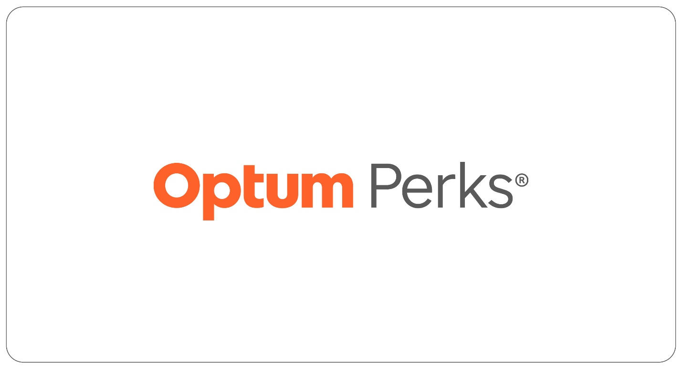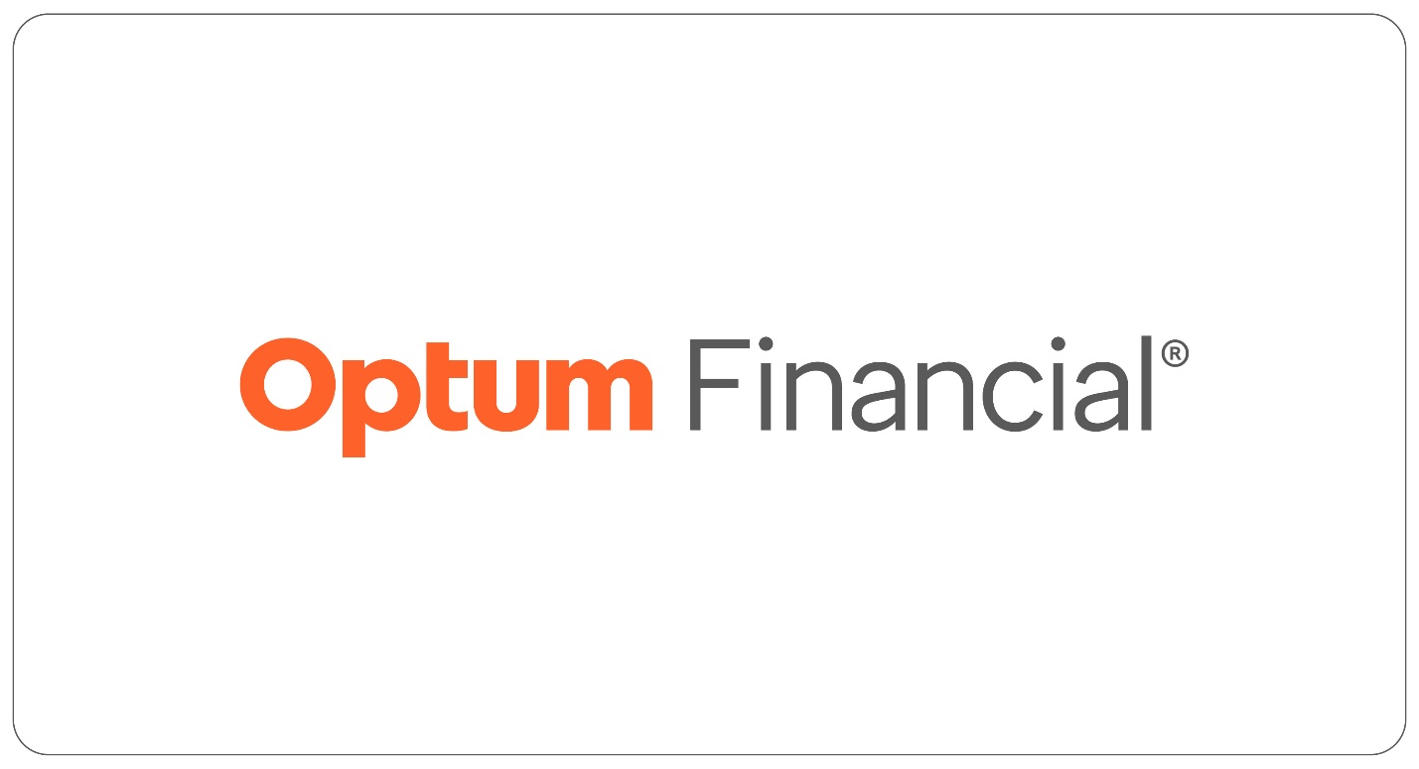

Products
Product families, product lines, and/or service offerings that are available for sale under the Optum primary brand or a sub-brand. When representing products and offerings, use plain text only, and do not lock it up next to the wordmark. First instances in body copy, please use the register mark after Optum.

Naming guidelines
Descriptive names help our audiences navigate the breadth and depth of products that are offered across the enterprise.
- Aligned
- Intuitive
- Familiar
- Simple
- Usable

Reference 'naming' in the brand stewardship playbook >

Examples
- Optum Advisory Services
- Optum Pay
- Optum Specialty Pharmacy
- Optum HouseCalls
- Optum Quit for Life

Endorsed
Endorsement treatments is an architecture strategy that leverages the brand equity and reputation of the primary brand while enjoying independent positioning, visual identity, personality and messaging for the third-party brand.
Adding the primary brand as an endorsement lends the endorsed brand legitimacy, authority and continuity. Endorsement treatments can apply to all audiences depending on business need (B2B, B2B2C and D2C) and what makes most sense for the audience and situation.
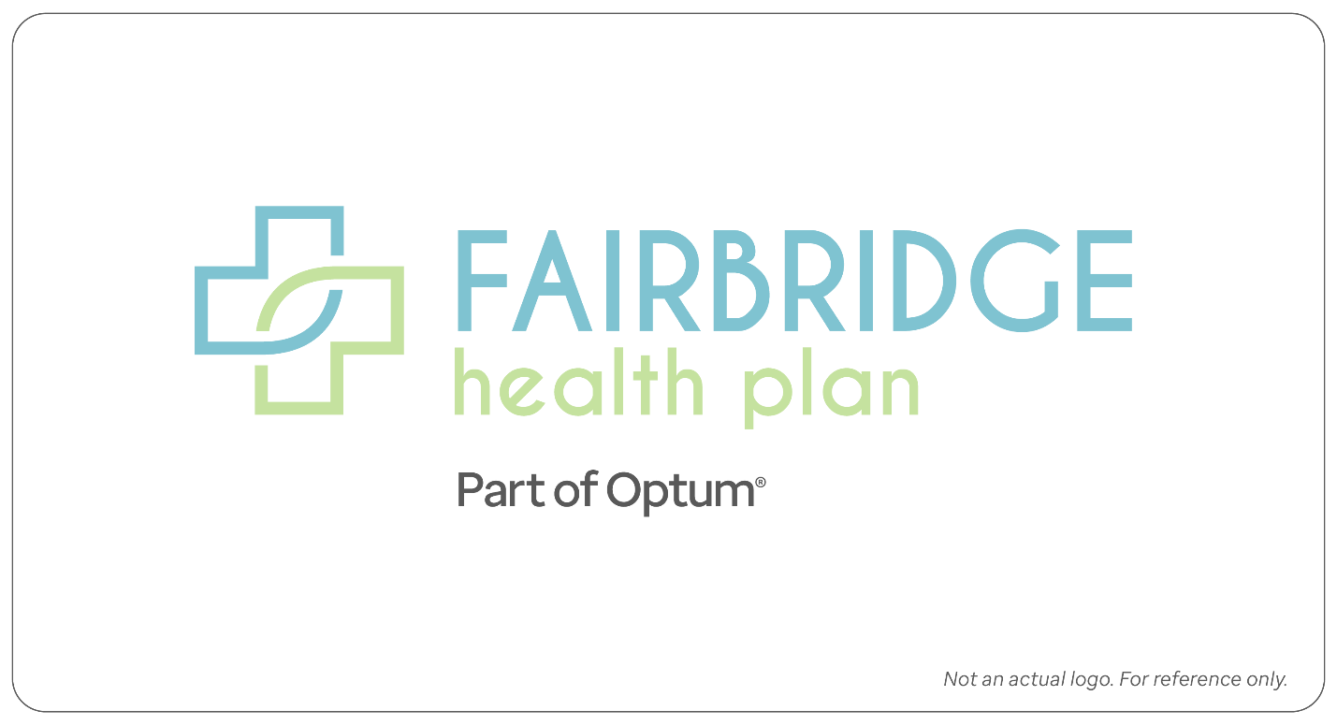
Part of Optum®: Used to increase familiarity during a brand transition from a legacy brand to Optum primary brand.

Partnership
A complementary collaboration between Optum primary brand and an external partner that benefits both brands. Lockup the partner brand to the right or left of the Optum wordmark.
If you need partnership lockup created, please request support via help desk.
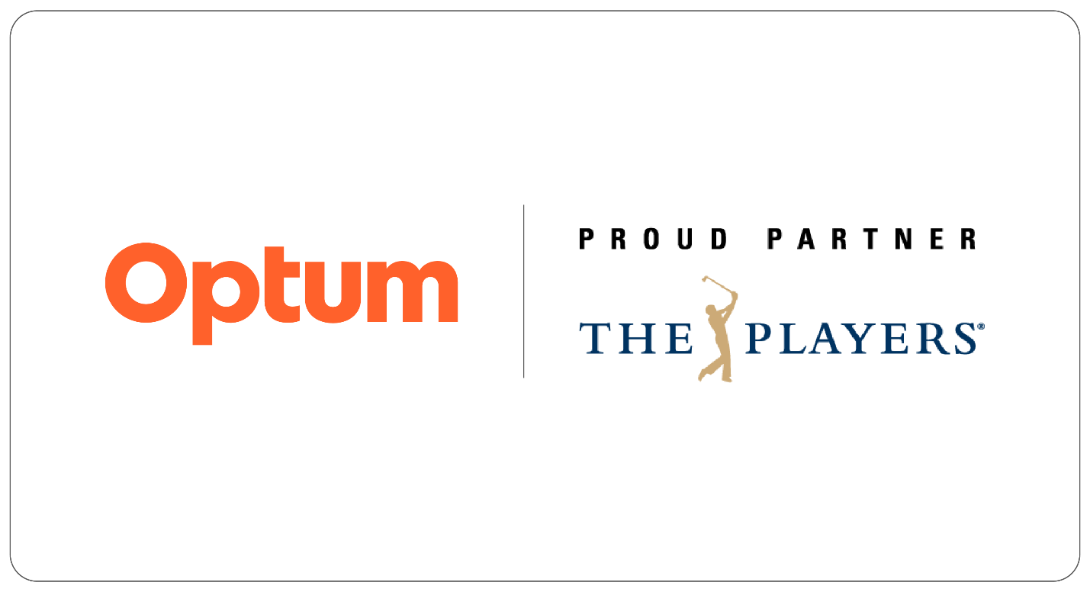
Primary position: When a communication is coming from Optum, the recommendation is to lead with the Optum wordmark first

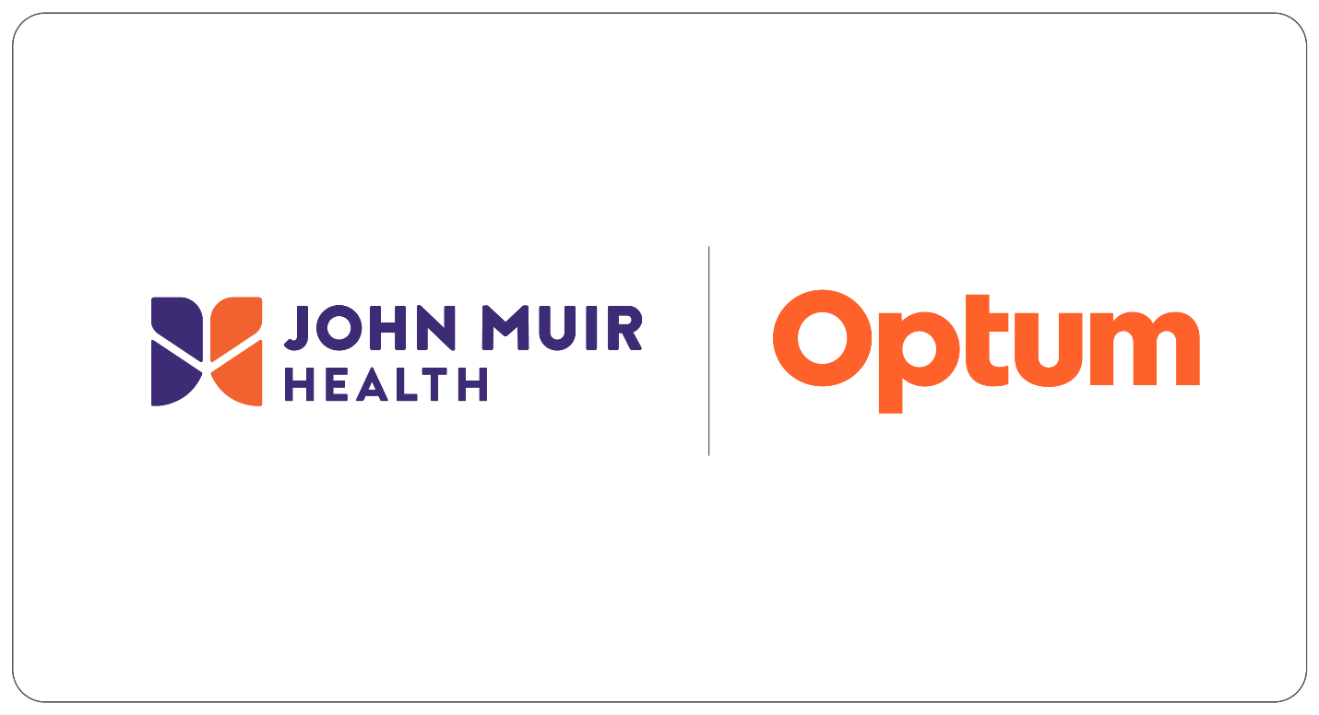
Secondary position: For situations where we lend our services or are embedded into a health organization, secondary representation is recommended.

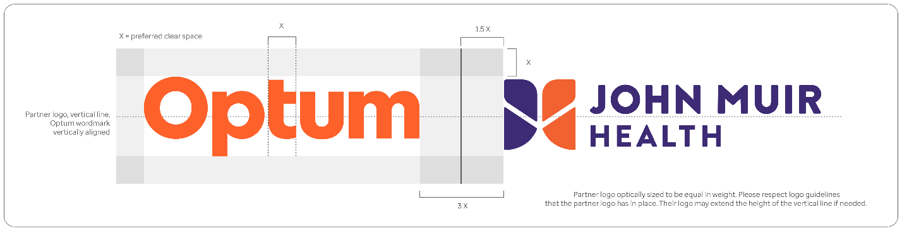
Styling: Partner logos are sized to be optically equal to the Optum wordmark. Divider line in Optum Dark Gray, extending the height of the wordmark's clearspace.

Standalone

A rare-case exception that allows entry into categories or verticals where the Optum brand is not suitable. Separation from the Optum primary brand is required to: Deliver value unrelated to "integrated whole health"; offering designed to compete with Optum; reputational conflict; execution limitations. Standalone brands will have their own brand guidelines. Do not mix Optum brand elements with standalone brands.
If you need help determining which brand to use, please request support via help desk.
Note: Does not reflect retired brands/brands in transition. Does not reflect care delivery organizations (CDOs) which will transition over time.

Special treatments
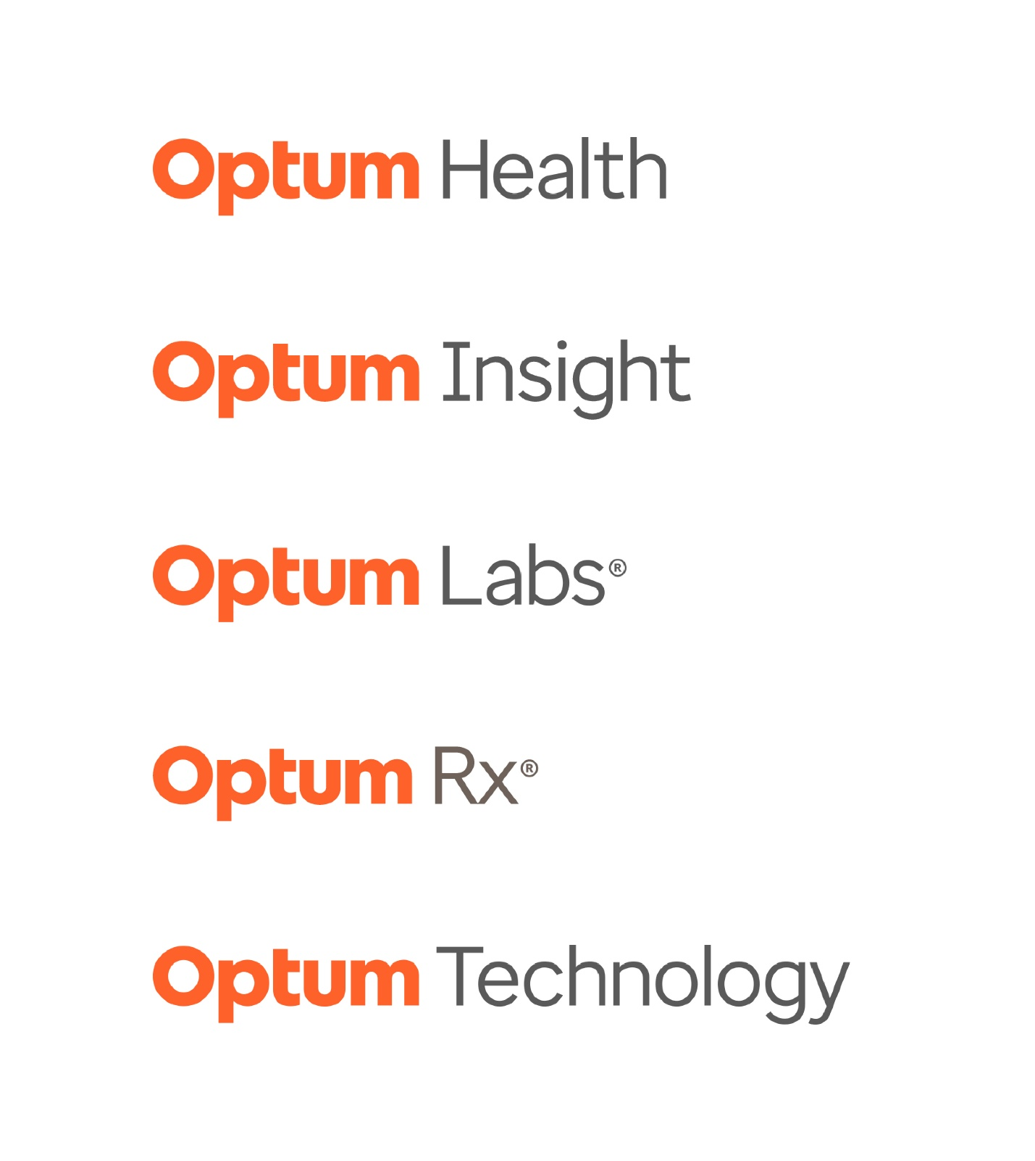
Business segments group a portfolio of capabilities for the purpose of external financial reporting. Approved business segments include Optum Health, Optum Insight, Optum Labs, Optum Rx, and Optum Technology.
They are approved to use our lockup formatting only for:
- Investor presentations
- Internal business segment presentations
Business segment wordmarks are not approved for use outside of these specific cases. Business segment can be included in plain text and secondary position alongside the Optum wordmark in email signatures, business cards, swag (internal use only), signage, and emails.
Reference page 30 of the brand stewardship playbook >

Internal business units, teams and programs
The Optum organization is one brand represented by our Optum wordmark. Business units, internal teams and programs are not brands and should represent themselves using plain text. This approach will help us build the iconic brand we need to support our business in the rapidly changing industry where we compete.
Use our approved fonts, Enterprise Sans or Arial, to represent business units, teams and programs. Follow typography sizing and color guidance.

Examples of use

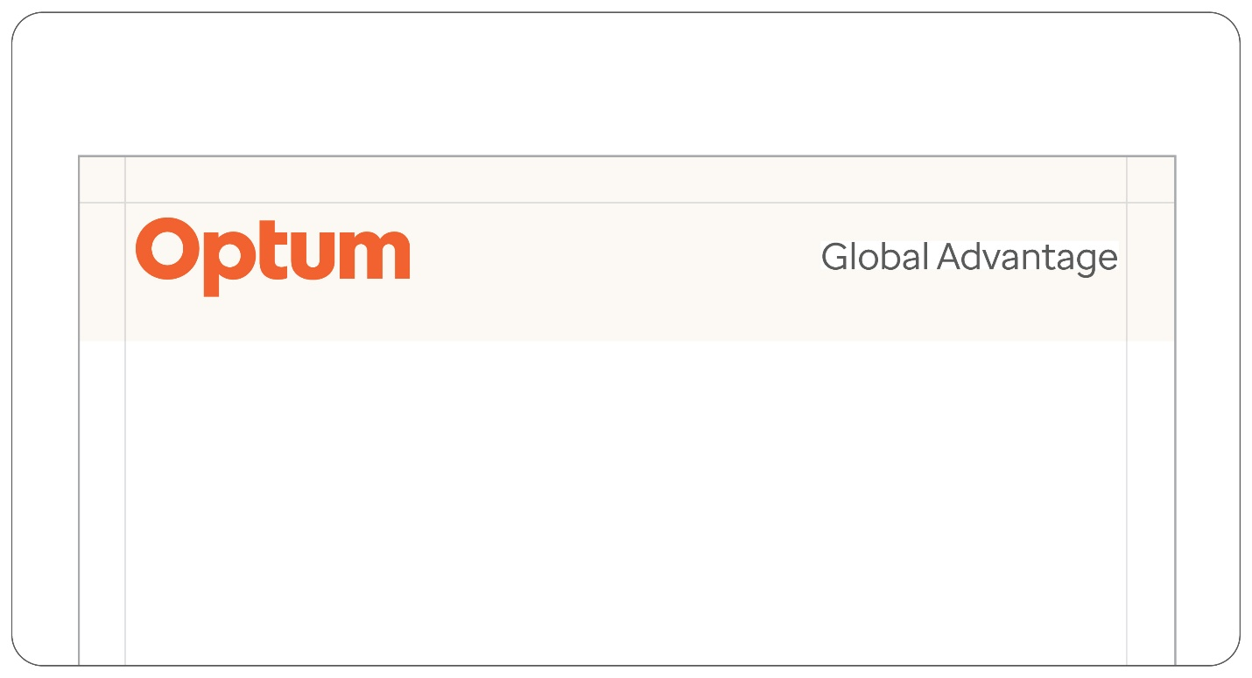
With Optum wordmark and secondary team placement. Team name set in Enterprise Sans Regular, using Dark Gray.

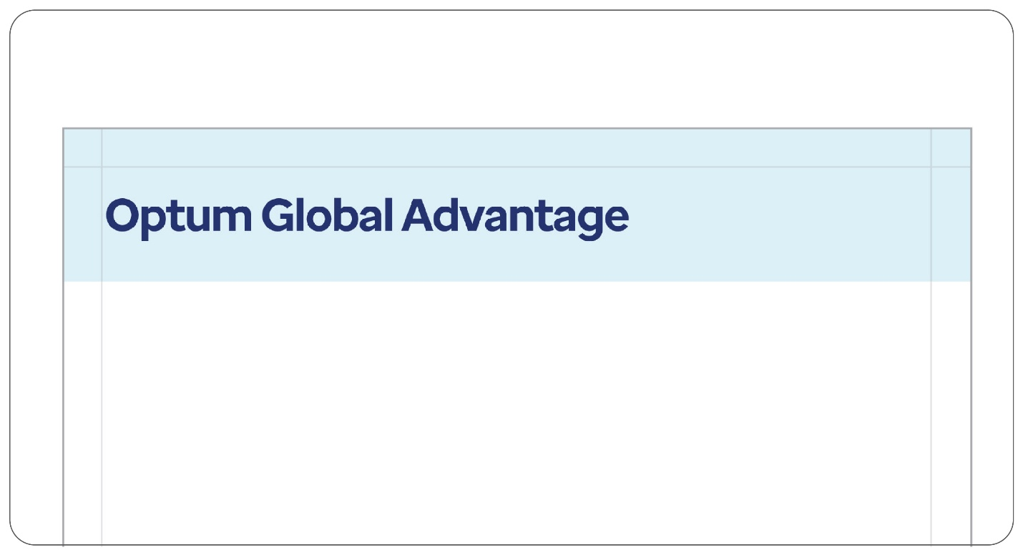
Without Optum wordmark. Team name set in Enterprise Sans Regular in primary placement. Typography guidance is followed as outlines (team name becomes Dark Blue as it is used as a headline and on the sky blue background.

Getting it right

Wordmark ≠ Info
It’s important to have a clear distinction between what is a wordmark, and what is information or copy. Use it as a header or footer, but never as part of informational text.

Product names use plain text

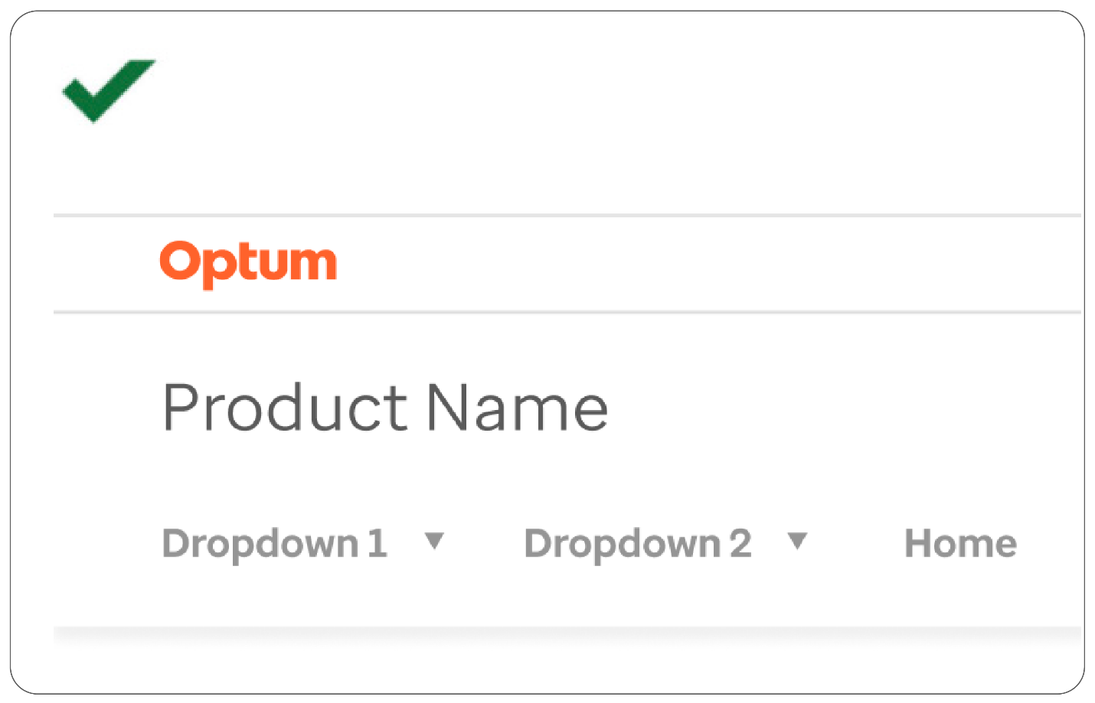
Product names use remote treatments. On apps, websites and tools, they appear below the primary brand or sub-brand.

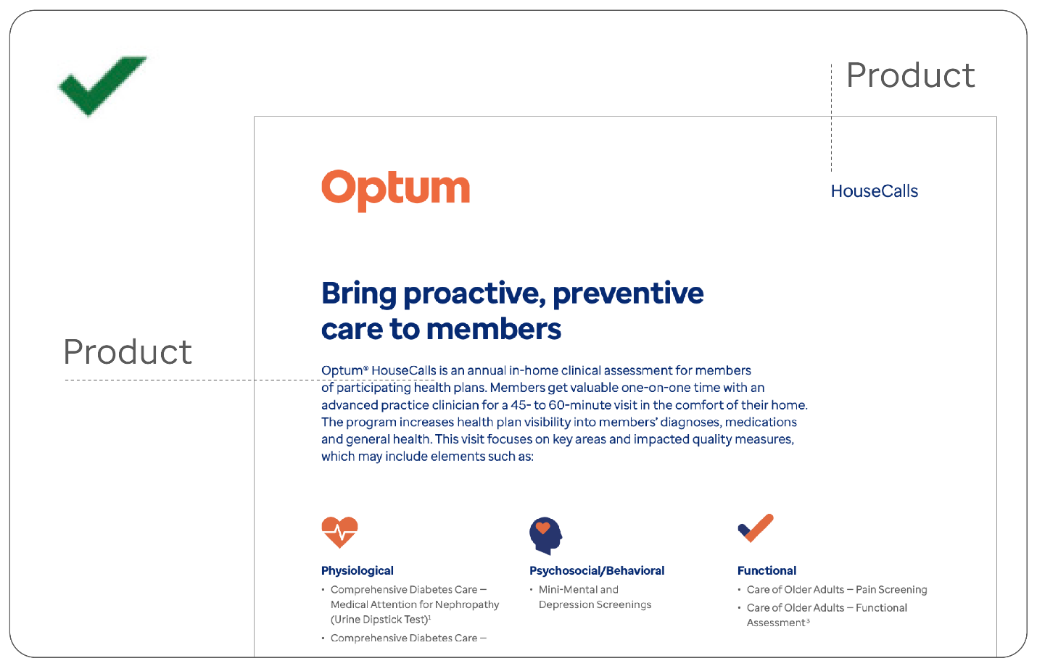
Don’t lock up product names next to word marks. They should only be used in prominent remote locations, or in headlines and body copy.

Guidance
Do not typeset the wordmark instead of using the sub brand file.
Do not put product or team names near the wordmark.
Do not create your own internal team wordmark.
Do not create new endorsement language.
Do not bottom align partnership lockups.
Do not go to market with new product and offering names without going through our brand naming review.
Do not create product wordmarks or stylize plain text.
Do not add our wordmark to endorsement text.

Standalone brands
A standalone brand is defined as a brand related to our primary brand, but set apart with its own unique branding due to significant legal or regulatory reasons.
This rare-case exception allows entry into categories or verticals where our brand is not suitable, as such we should avoid mixing these brand with our primary brand in any way.
Having a standalone brand outside of the Optum primary brand is required when:
- Delivered value is unrelated to "integrated whole health"
- Offering designed to compete with Optum
- Reputational conflict
- Legally and contractually required
If you have questions or need additional information please contact Optum Brand Center help desk.

Brand Voice Overview

Who we are

Your inspired advocate
We’re in this together. We’re imagining a world where everyone has the chance to achieve their best health. And what centers us are the people we help and the communities where we live as well as our connection with one another. We're committed to changing health care and delivering a simple, personal experience across every moment of care. With our hands at work across all aspects of health, we connect people and information to create a healthier world, one insight, one connection and one person at a time.

Genuine
- Intuitive, approachable and uncomplicated
- Honest, inclusive, straightforward and balanced
- Thoughtful in applying our knowledge and experience for the sake of progress and benefit of all
- Meet people where they are and yet willing to challenge assumptions — both our own and others

Compassionate
- Mindful of opportunities to increase equity
- Always empathetic, providing comfort and peace of mind
- Proactive and generous in the use of our resources to help others
- Personal in our recommendations and solutions, supporting achievement of individual goals

Optimistic
- Building a sense of community and belonging
- Forward thinking and acting, in it for the long term
- Inspired to do more, and dedicated to bringing better health to more people

Collaborative
- Making advancements in health care accessible for everyone
- Build confidence by connecting people to the right insights at the right time
- Working together on everyday improvements toward a health system that works better for all

How we speak

Brand voice
Optum uses a voice that’s genuine, compassionate, optimistic and collaborative. This guide will help you hone your own writing voice to match that of Optum.
Write as though you’re having a one-on-one conversation. Whatever it is, make the person reading it feel as though it’s a message meant exclusively for them.

Genuine
Being genuine means communicating with people in a way that puts them at ease. That’s especially important in the case of a health care company because many among our audience are in the midst of trying circumstances. Prioritize practicality and honesty over cleverness and business-speak — even when speaking about business.

Getting it right

Do
- Be smart
- Start with the key point
- Focus on one message
- Think about messaging hierarchy
- Be simple, easy-to-use and conversational

Do examples:
"It doesn’t have to be flu season … for you."
"What’s keeping you up at night?"
"Let’s talk about it."

Don't
- Be cute
- Include too many ideas in one headline
- Go overboard with extra words
- Repeat things in different places
- Be overly complex or overly simplistic

Don't examples:
"Say BOO to the flu!"
"Sleep problems may lead to heart disease."

Compassionate
Being compassionate is at the very heart of what Optum does. And being compassionate means being inclusive and making room for each person and their individual circumstances. It also means getting to the point; our compassion extends to not wasting people’s time.

Getting it right

Do
- Use empathy to establish trust
- Acknowledge a situation
- Give examples of understanding
- Get to the point; value your audience’s time
- Focus on choices and options

Do examples:
"If it matters to you, it matters to us."
"Managing diabetes can be easier with help."
"You have more support than you know."

Don't
- Sound overly emotional or sentimental
- Dwell on negative aspects of a situation
- Avoid tough subjects
- Include too much exposition
- Narrow your audience’s choices for them

Don't examples:
"We care deeply about your health."
"Managing diabetes is extremely difficult."
"You’re not alone."

Optimistic
Our fundamental belief in people keeps the Optum voice positive. Not only that, an optimistic outlook creates better outcomes and helps people better deal with difficult times. That said, our type of optimism isn’t that of frenetic cheerleading; there’s a degree of humility, restraint, and a focus on reality. But we do want people to feel as though things are going to be alright.

Getting it right

Do
- Focus on the good
- Stay relevant with the subject
- Talk about what’s possible
- Employ wit or humor, when relevant
- Reframe to see the big picture

Do examples:
"A good solution for a good night’s sleep."
"Yes, there’s a better way to feel better."
"A journey of a thousand miles begins with a single app."

Don't
- Be naïve or sound flippant or insensitive
- Use the same tone at all times
- Set unrealistic expectations
- Rely on puns or play on words
- Avoid a subject or dance around it

Don't examples:
"Don’t lose sleep over losing sleep."
"Getting better can be fast and easy."
"The journey ahead may be difficult, but you have help along the way."

Collaborative
We consider every interaction and communication with our audience a form of collaboration. But ultimately they have to take the next step for themselves. So while we can’t — and shouldn’t — command them to do something, we can show them the way and give compelling reasons for going in that direction.

Getting it right

Do
- Show people the path
- Sound confident, open and supportive
- Inspire, be playful, have fun
- Focus on “you” whenever possible
- Share next steps

Do examples:
"Team up with someone who’s got your back."
"Let’s get started."
"Designed with you in mind."

Don't
- Insist that people walk a certain way
- Come across as boastful
- Sound promotional or sarcastic
- Use “we” or “us” excessively or be too self-focused
- Leave people feeling uncertain

Don't examples:
"We help more people in more ways than anyone else."
"We’re here to help."
"We solve for your needs."

Our audiences

Optum serves business-to-business (B2B), business-to-business-to-consumer (B2B2C), and business-to-consumer (B2C) and direct-to-consumer (DTC) audiences. Our audiences are people first, no matter their role, and people are at the heart of what we do. Here are definitions of terms we use at Optum to describe our audiences.
- Business-buying audience (health system buyers): Used to describe our target audience for B2B offerings and communications. It reflects those who purchase services from us across the segments: health plans, providers, employers, government and life sciences organizations.
- Customers vs. clients: We refer to our business-buying audience with whom we have a relationship as customers, rather than clients. Whenever possible, refer to customers as organizations or individuals.
- Consumers: Used to describe the end user of our health care services. The preference is people, families or individuals, followed by consumers if we need to broadly differentiate from our customers.
- Members: Members is acceptable when speaking about the individuals and families served by a health plan or pharmacy benefit manager (PBM), although people or individuals is preferred.
- Employees: Employees is acceptable when speaking to an employer about those who work for them or to delineate our B2B2C audiences. People or individuals is preferred.
- Participants: Participants is used by some business units to represent those people who partake in their services. While acceptable, people or individuals is preferred.
For more information on your target audience, including persona information, please contact your marketing partner.

Messaging

Optum descriptions
Utilize messaging for any Optum audience.

All your health needs, all in one place

Short​
We’re evolving health care so everyone can have the opportunity to live their healthiest life. Together, for better health.

Long​
We’re evolving health care so everyone can have the opportunity to live their healthiest life. It’s why we put your unique needs at the heart of everything we do, making it easy and affordable to manage health and well-being. We are delivering the right care how and when it’s needed; providing support to make smarter and healthier choices; and making prescription services easier, while helping you save money along the way. It’s everything health care should be. Together, for better health.

Boilerplate
Optum is a leading information and technology-enabled health services business dedicated to helping make the health system work better for everyone. With more than 215,000 people worldwide, Optum delivers intelligent, integrated solutions that help to modernize the health system and improve overall population health. Optum is part of UnitedHealth Group (NYSE: UNH). For more information, visit optum.com.

Enterprise descriptions
Utilize messaging for any UHG or investor audience.
UnitedHealth Group is a health care and well being company with a mission to help people live healthier lives and help make the health system work better for everyone.
We are 340,000 colleagues in two distinct and complementary businesses working to help build a modern, high performing health system through improved access, affordability, outcomes and experiences. Optum delivers care aided by technology and data, empowering people, partners and providers with the guidance and tools they need to achieve better health. UnitedHealthcare offers a full range of health benefits, enabling affordable coverage, simplifying the health care experience and delivering access to high quality care.
We work with governments, employers, partners and providers to care for 146 million people and share a vision of a value based system of care that provides compassionate and equitable care. At UnitedHealth Group, our mission calls us, our values guide us and our diverse culture connects us as we seek to improve care for the consumers we are privileged to serve and their communities.

Health care vs. healthcare
While “healthcare’” and “health care” may seem interchangeable, context matters. Use 2 words when speaking to consumers and B2B audiences about the care we deliver. We use the 1-word version when referring to the “industry” or “system.”
A few examples of usage:

Health care​
- We strive to make access to quality health care easier and more affordable.
- Your health care is important to us​
- Use your income tax-free HSA funds to cover eligible health care expenses and save for retirement​.
- 49% of consumers wish the digital health care experience mirrored Amazon, Netflix or Uber ​

Healthcare​
- We help healthcare leaders navigate change and drive growth while reducing the cost of care​.
- The healthcare industry is undergoing a monumental site-of-care shift.​
- With extensive hospital operations experience at the executive level, she understands how the healthcare system works and where there are opportunities to improve it.​

Things to keep in mind​
Try to avoid situations in which both the 1- and 2-word versions are used in the same communication. Ask yourself if either one is needed. Is there a way to rephrase a line to eliminate the need to use the term “health care”? Could it instead be “health and well-being"? Or simply “health” or “care”? Could “healthcare” be substituted for “the health system”? Don’t feel like you’re handcuffed to use either. We have the freedom to be creative with alternate phrasing.

Content Best Practices

Health literacy principles

There are two types of health literacy:
- Personal health literacy is the degree to which a person can find and understand basic health information to make good health decisions.
- Organizational health literacy is the degree to which organizations help individuals find, understand and use information and services so that they can make good health decisions for themselves and others.¹
Most Americans (88%) are not considered “proficient” when it comes to health literacy. More than one-third fall into the “basic” or “below basic” level. That means many of us are unable to make informed decisions about our health. People age 65 and older, people of color and adults living below the poverty level are more likely to have low health literacy.²
Limited health literacy is connected to poor health:
- Being unable to manage chronic diseases like asthma, diabetes and HIV/AIDS
- Not knowing how to take medications correctly
- Not understanding treatment plans well enough to follow them
- Ending up in the hospital more often
Limited health literacy is also expensive. Improving health literacy in the U.S. could prevent nearly one million hospital visits and save over $25 billion a year.³
Tools for health literacy
- Writer AI tool. A content editing tool that assesses a document’s readability. It also includes style guides for UnitedHealth Group, UnitedHealthcare and Optum. To request a license to use Writer, visit Getting Started with Writer. To learn more, see these tools and videos.
- Just Plain Clear® glossary. A resource providing more understandable words for complex terms. The glossary also includes the Uniform Glossary, a list of health care terms established by the federal government.
- LearnSource Health Literacy Overview (272969). This course provides an introduction to health literacy. It is intended for any UnitedHealth Group employee who needs general health literacy awareness training.
- Health literacy Sparq page. A resource hub for employees. Also includes frequently asked questions and writer’s guides.
- Health Literacy Viva Engage page. Community group for employees to share health literacy information with peers and ask questions.
- Health Literacy Online. From the Dept. of Health and Human Services. A guide for writing web content with health literacy in mind.
- The Centers for Disease Control and Prevention health literacy site. Offers resources, training, research and updates.
Sources
1. Office of Disease Prevention and Health Promotion, U.S. Department of Health and Human Services. Healthy People 2030.
2. The health literacy of America’s adults: Results from the 2003 National Assessment of Adult Literacy (ed.gov).
3. UnitedHealth Group. Improving health literacy could prevent nearly 1 million hospital visits and save over $25 billion a year. 2020.

Readability

Why readability is important

Readability has a powerful effect on conversion rates
- Clear writing is critical because confused readers don’t buy, don’t click — they bail.
- We only have eight seconds to capture an online reader’s attention.¹
- Most online readers (79%) merely scan the content on a page.²
- The clearer the value and relevance, the higher the probability of conversion.³

A lower reading level is better for business
- 50% of adults can’t read above an 8th grade level.
- According to the U.S. Dept. of Education, the average adult reads at a 7th or 8th grade level.⁴
- Even though our B2B audience tends to be college educated, even highly literate readers prefer copy that is easier to read.⁵

Readability affects search engine rankings
Google has made good readability — which equates to good engagement — a ranking signal for how websites appear in search.⁶
Moz’s 2015 Ranking Factors Experts Survey and Searchmetrics 2015 Ranking Factors Study names reading level as one of the hundreds of things that affect search engine rankings.
Moz found reading level even outranks use of video/images/slides in terms of influence over how high a page appears in the search results.⁷ Searchmetrics found that Google’s top 10 pages have a lower reading level than the pages that follow.⁸

Writing at a lower reading level
- Isn’t “dumbing things down”
- Makes content accessible to everyone — even people with PhDs
- Saves time for busy professionals, making information quickly read and actionable

How to write clearly
- Write short sentences (15–20 words or fewer). Express one idea per sentence (avoid compound sentences). It’s ok to start a sentence with And or But. But do not use a comma after either of them.
- Use the shortest word. Words three syllables or more are flagged by VisibleThread and Flesch-Kincaid.
- Use the active voice, not passive.

Optum readability standards
Consumer-facing copy:
- 8th grade or lower for most audiences
- 6th grade or lower for Optum Care and Medicare audiences
- 4th grade or lower for Medicaid audiences
Business-facing copy:
- 9th grade or lower

1. Time. You now have a shorter attention span than a goldfish. Accessed January 21, 2021.
2. Forbes. The most overlooked factor of content marketing? Scannable content. Accessed January 21, 2021.
3. Act-on. What every B2B marketer needs to know about readability. Accessed January 21, 2021.
4. Ibid.
5. Nielsen Norman Group. Lower-literacy users: Writing for a broad consumer audience. Accessed January 21, 2021.
6. Act-on. What every B2B marketer needs to know about readability. Accessed January 21, 2021.
7. Moz. Search Engine Ranking Factors 2015. Accessed January 21, 2021.
8. Act-on. What every B2B marketer needs to know about readability. Accessed January 21, 2021.

Writing about mental health

At Optum, we write knowing that people are people, not conditions. If a person lives with a mental health condition, it’s just one part of their complex and meaningful life. So when we write, it’s to provide meaningful support while improving awareness and understanding of mental health and emotional well-being.

What we’re talking about
Writing about mental health and emotional well-being covers a wide range of topics. It includes anxiety, depression, substance use, suicide, PTSD and psychosis. But it also includes resiliency, treatment and recovery.

Words help combat stigma
For many, living with a mental health condition also means living with stigma: their own feelings of shame or of being judged, and others’ biased attitudes about mental health conditions and those with them. Stigma doesn’t just keep people from talking openly about mental health, it can also keep them from seeking the care they need. That’s why the words we use are so important.

General rules when writing about mental health
- Don’t use words that imply pity, judgment or shame. Rephrase from someone who suffers from mental illness to someone who lives with a mental illness or someone who is affected by mental illness. Also, rephrase from someone who committed suicide to someone who died by suicide.
- Don’t refer to someone only by their disease, such as a schizophrenic person. Instead, use a person-first approach. Say a person living with schizophrenia or someone diagnosed with schizophrenia. Also, don’t describe people or things as bipolar, e.g., Adam is bipolar or this weather is so bipolar.
- Remove certain words from your vocabulary. Crazy, nutty, head case, lunatic, psycho, schizo and similar words reinforce stereotypes and minimize the importance of truly understanding mental health conditions.

Guidance on finding the right words

Do: Use; uses – e.g. {Person who uses drugs
Don’t: Abuse, abuses
Do: Person with substance use disorder
Don’t: Addict

Do: Living with, diagnosed with, with, who has, etc. – e.g. Person who has schizophrenia
Don’t: Afflicted with
Do: Person with alcohol use disorder
Don’t: Alcoholic
Do: Alcohol use disorder or substance use disorder (if speaking more broadly)
Don’t: Alcohol problem
Do: Person who has anorexia, someone diagnosed with anorexia, etc.
Don’t: Anorexic, anorexics
Do: Anxiety, depression and other conditions should not be capitalized
Don’t: Capitalize conditions or disorders, e.g. General Anxiety Disorder – Exception: Conditions preceded by a name should be capitalized, e.g., Tourette syndrome
Do: Abstinent, note actively using
Don’t: Clean
Do: Tested negative for substance use
Don’t: Clean drug screen
Do: Died by suicide
Don’t: Committed suicide
Do: Actively using
Don’t: Dirty
Do: Tested positive for substance use
Don’t: Dirty drug screen
Do: Person with substance use disorder
Don’t: Drug abuse, drug misuse, harmful use, drug abuser, drug addict, druggie, etc.
Do: Substance use disorder
Don’t: Drug problem, drug habit
Do: Person in recovery, person in long-term recovery
Don’t: Drug problem, drug habit
Do: Diagnosed with a mental health condition – e.g. Person with a mental health condition
Don’t: Mentally ill, mental illness
Do: Concern, condition, issue (depending on context) – e.g. His wife was concerned he was living with alcohol use disorder
Don’t: Problem – e.g. His wife was concerned he had a drinking problem
Do: Living with, diagnosed with, with, who has, etc. – e.g. Person who has schizophrenia
Don’t: Suffers from
Do: Living with, diagnosed with, with, who has, etc. – e.g. Person who has schizophrenia
Don’t: Victim of
Use “behavioral health” for B2B audiences only. Use “mental health” for consumer audiences. Please see the Terminology section of the Brand center.
Please note: The terms in this list haven’t been tested for health literacy. If you are creating consumer-facing materials, please work with your team to ensure that the terms you use fit your readers’ needs.

Editorial Guidelines

Quick editorial guide

Optum style follows guidance from the Associated Press (AP) Stylebook and Merriam-Webster dictionary. In addition, technical writers follow guidance from the Microsoft Writing Style Guide.

*Change in editorial style regarding health care/healthcare
Use 2 words "health care" when speaking to consumers and B2B audiences about the care we deliver. Spell "healthcare" as one word when referring to the “industry” or “system.” For more information and examples, see Health care vs. healthcare on the Messaging page.
Below are highlights of the Optum editorial style guide. For more detailed guidance, see punctuation and formatting, capitalization and other chapters listed under the Brand Center’s Voice tab. For any questions, please log in and send requests through Help Desk.

Getting it right

Never use Optum or its brands as a possessive (Optum’s).
Correct: “Optum solutions…”
Wrong: “Optum’s solutions…”
Correct: “At Optum, we’re working to create a healthier world for everyone.”
Wrong: “Optum’s working to create a healthier world for everyone.”
To maintain rights in the specific brand name, trademarks must appear precisely as they are registered or applied for. As a trademark acts as an adjective instead of a noun (e.g., Optum® Data Analytics Services), it should not be used in the possessive form as it would dilute the trademark’s legal significance.

Only use a serial comma in the case of complex lists.
Correct: “Find phone numbers, emails, websites and more to assist you.”
Wrong: “Find phone numbers, emails, websites, and more to assist you.”

Use sentence-case capitalization in all headings, both print and online.
Correct: “Optum solutions for providers”
Wrong: “Optum Solutions for Providers”

Only actual product or service names should be capitalized. Avoid capitalizing Optum capabilities and generic offering descriptions.
Correct: “Optum Pay”
Wrong: “Payment Solutions for Providers”
Correct: “Creating digital transformation strategies that put the patient first”
Wrong: “Creating Digital Transformation Strategies that put the patient first”

For time, use a.m. or p.m. (lowercase, with periods).
Correct: “10 a.m.”
Wrong: “10 am”
Correct: “2 p.m.”
Wrong: “2:00 pm”

If bullets are not complete sentences, do not include periods. See more guidance in punctuation and formatting (described in the chapter Punctuation and formatting below).
Correct:
- Same-day appointment with our health professionals
- Access from all 50 states
- Predictable, flat-fee prices starting at $55
Wrong:
- Same-day appointment with our health professionals.
- Access from all 50 states.
- Predictable, flat-fee prices starting at $55.

Phone numbers should be formatted with hyphens only. For U.S. and Canada, include “1” whenever listing a phone number. For international numbers include “+1”. When including letters, make sure to include numerals as well.

Correct: “1-800-123-4567”, “+1-123-456-7890”
Wrong: “1 800 123 4567”, “+1.123.456.7890”, “(800) 123-4567”

Guidance

Do not use more than one space between sentences.
Example:
Better health care is designed around you. That includes when and where you need it – even at home – from providers who really listen to you. Find out more.

Do not use ampersands
Example:
Individuals & families

Do not use more than one exclamation point — and use the exclamation point sparingly.
Example:
Helpful ways to manage your stress!!!

Do not use optum.com as the first word in a sentence.
Example:
Optum.com can put you in touch with the right people, select from one of the options below.

Do not capitalize optum.com.
Example:
Optum.com

Do not use www. in URLs.
Example:
www.optum.com

Do not use periods in abbreviations or initialisms, including academic degrees.
Example:
Ph.D.

Do not use em dash without space before and after.
Example:
We’ve put our focus on what really matters—you.

Do not use en dash with space on either side.
Example:
Ages 12 – 18

Capitalization

Titles and headlines

Titles, headlines and subheadings within a document or asset
Follow sentence-case capitalization on all materials, both print and online. A headline, heading or subheading should not include end punctuation unless it is a question, or unless directed otherwise by a silver platter for the digital marketing platform (DMP).
Examples:
Health literacy principles
Are you ready for the new CMS rules?
Or if a title has a colon:
Optum style guidelines: A primer

Product or service names
Refer to the Taxonomy Catalog. Names of Optum products and services are capitalized. “Optum” should precede the name of the product or service upon first use in text.
Examples
The Optum Condition Management program helped Jane manage her diabetes.
Examples of product names:
Wellness Coaching
Payment Integrity Consulting
On-Site Ergonomics
Do not capitalize Optum capabilities, constituent groups or generic offering descriptions. Exception: when used with “Presented by” as shown in the examples below, under "Job titles."
Examples:
Optum regional account manager (RAM) network computer-assisted coding solutions
Sentence example: Optum payment solutions help align payer and provider objectives.

Department names
Title case the department name but do not capitalize the word department and/or team when it follows a formal name.

Events
Use title case capitalization for names of events such as podcasts, webinars, conference presentations and workshops.

Job titles
Do not capitalize general job titles such as doctor or wellness coach. Lowercase in prose when the title comes after the name, uppercase when title appears before the name.
Chief Executive Officer John Doe spoke to a crowd of 4,000 health care professionals.
… said Jane Doe, chief executive officer, Acme Company.
Contact a disease management nurse.
However, if the name and title will be displayed on their own as in a bio caption or “presented by,” job title is in title case.
Jane Doe, Chief Executive Officer, Acme Company
John Doe is the chief executive officer of XYZ Technologies.
Presented by:
John Doe, Chief Executive Officer, XYZ Technologies

After colons
In text, capitalize the first word after a colon only if it is a proper noun or the start of a complete sentence:
She promised this: The future will bring rapid change.
There were 3 considerations: expense, time and feasibility.

Publications/media titles
Format/doc type | Element | Style | Examples
Article (magazine, newspaper or online) | Title | Sentence case | - Placebo effects in medicine  - When referenced in copy: “Placebo effects in medicine” (in quotes)  - In a source note: Kaptchuk TJ, Miller FG. Placebo effects in medicine. N Engl J Med. July 2, 2015:373(1):8–9.  - Note: Per American Medical Association guidelines (which Optum style follows), abbreviate journal names in source notes. To find an abbreviation, go to this site and enter the journal name in the search box.. For consumer-facing documents, titles of journals may be spelled out for clarity, e.g., New England Journal of Medicine rather than N Engl J Med.
Book | Title | Title case, italic | - The American Health Care Paradox  - In a source note:  Bradley EH, Taylor LA. The American Health Care Paradox. New York: Public Affairs; 2013.
Case study | Title | Sentence case | - Colorado Springs Health Partners drives patient-centered medical home with analytics from Optum
e-book | Title | Designer's choice: Title or sentence case case (not italicized) | - Managing the Epidemic: A Guide to Complex Drugs  - When referenced in copy, use quotation marks: “Managing the Epidemic: A Guide to Complex Drugs”
Headline, heading, subheading | Headlines, headings, subheadings and banner ads | Sentence case (punctuate as appropriate) | - Complex condition management  - Know your numbers  - Sign up for our free webinar.
Infographic | Title | Designer's choice: Title or sentence case (not italicized) | - Driving the adoption of health savings accounts  - When referenced in copy, use quotation marks: “Driving the adoption of health savings accounts”
Job titles | Job title | In text, uppercase when the title appears before the name; lowercase when the title comes after the name.  Use title case when the name and job title appear outside of body copy, for instance, in bio sketches, image captions and emails/posters/drop cards listing presenters | - Chief Executive Officer John Doe spoke to a crowd of 4,000 health care professionals.  - John Doe is the chief executive officer.  - Presenter: Jane Doe, Chief Executive Officer, Acme Company  - But if Jane Doe is quoted in text, title should be lowercase: says Jane Doe, chief executive officer, Acme Company.
Magazine/Journal | title | Title case, italic | - Journal of the American Medical Association  - In a source note: Per AMA guidelines (which Optum style follows), abbreviate journal names in source notes unless the work is consumer facing. Find an abbreviation here by entering the journal name in the search box.
Newspaper | Title | Title case, italic | - New York Times
Podcast and episode titles | Title | Title case (not italicized) | - Seeing the Bigger Picture: Using Data and AI to Fuel Insights  - Strategies for Advancing the Revenue Cycle  - When referenced in copy, use quotation marks: “Strategies for Advancing the Revenue Cycle”
Presentation (as at a conference) | Title | Title case | - Total Population Health Overview  - When referenced in copy: “Total Population Health Overview” (in quotes)
Study | Title | Title case | - The 9th Annual Wellness in the Workplace Study  - When referenced in copy: “The 9th Annual Wellness in the Workplace Study” (in quotes)
Video | Title | Title case, italic | - Get in the Analytics Game: Know Your Population
Webinar | Title | Title case | - Oncology Issues and Solutions  - When referenced in copy:  - “Oncology Issues and Solutions” (in quotes)
White paper | Title | Sentence case | - Telehealth today: Evolving to meet health care demands in the 21st century  - When referenced in copy: “Telehealth today: Evolving to meet health care demands in the 21st century” (in quotes)
Workshop | Title | Title case | - Wellness in the Workplace workshop  - When referenced in copy: “Wellness in the Workplace” workshop (in quotes)

Punctuation and formatting

Punctuation and design
Punctuation immediately following a word should carry the same style elements as that word.
Do: Rely on our registered nurses for 24/7 support.
Don’t: Rely on our registered nurses for 24/7 support.
This rule does not apply to punctuation following a hyperlink. For instance, in an endnote or a footnote where you're hyperlinking an article title to the URL, do not include the period that follows the article title as part of the hyperlinked text.
Do: Read our Quick editorial guide.
Don't: Read our Quick editorial guide.

Abbreviations
Unless the abbreviation is a common one and/or very familiar to the intended audience, always spell it out on first usage and have the abbreviation follow immediately in parentheses. The abbreviation can be used in subsequent instances. However, if the full term is an important keyword for SEO, make sure to use that throughout the content.
Use the two-letter, postal abbreviations for states when space is at a premium (for example, in tables and graphs). In general text, spell out state names.
Do not use periods in most abbreviations. However, use periods in the case of U.S. for United States.
Example:
The Optum® Enterprise Computer-Assisted Coding (CAC) solution can help you increase accuracy in operations. Rely on CAC for all your coding needs.
Note: Whether you need to spell out the full name or term depends on the familiarity and needs of your audience. For instance, for Medicaid officials, CMS makes perfect sense; no need to spell out “Centers for Medicare & Medicaid Services.”

Academic credentials
Do not include periods with academic credentials (contrary to AP). Examples: PhD, MD, MBA.
Do not capitalize general degrees or the area of study: master’s degree, bachelor’s degree, master’s of public policy, master’s in Russian literature. Formal degree names should be capitalized: Bachelor of Arts, Bachelor of Science, Master of Arts, Master of Science, Master of Business Administration.
Include apostrophe for master’s degree and bachelor’s degree, not for doctorate or associate degrees. (No apostrophe when the formal degree is used, such as Bachelor of Arts, Master of Science, etc.)
If possible, specify a person’s degree with his or her name (ex: Sanjay Gupta, MD). Never use both the honorific “Dr.” with a degree (Dr. Sanjay Gupta, MD). Use “Dr.” on first mention in body copy. Use as appropriate on subsequent references.
If possible, reserve the honorific “Dr.” for health professionals only (medical doctors, allopaths, osteopaths, dentists, chiropractors, and even holistic healers and vets) and not for lawyers, academics and scientists (use PhD for them).

Ampersands
Spell out and. Do not use & unless it is part of an approved product or company name.
(Ex: Optum Home & Community Care)
Exception: & is allowed in charts and infographics, where space is limited.
When the symbol is used, it should appear at the end of the first line of a headline rather than at the beginning of the second (run-over) line.

Apostrophes
Add ‘s for a singular noun that ends in s, even when the next word starts with an s: hostess’s seat, hostess’s invitation, CMS’s September ruling, CMS’s plans. Do not use a possessive apostrophe with Optum. Note: This rule also applies to all sub-brands.
Do: Optum software solves that problem.
Don’t: Optum’s software solves that problem.

Asterisks
An asterisk (used to indicate a corresponding note) should be placed at the end of a sentence or at the end of a clause. It follows any punctuation mark except for the dash, which it precedes. It follows a closing parenthesis. This may vary depending on the font but use this format when possible.
Example:
If you have any questions or concerns, you also can speak with a personal wellness coach by calling 1-888-555-0321.*

Bios
In professional bios, use the subject’s full name on first mention in body copy. On subsequent mentions, use the first name only. As appropriate, use “Dr. [Last Name]” on subsequent mentions for doctors.

Bold
In all materials, whether online or print, use bold for references to user-interface text or an action to take online. Examples:
- For more guidance on punctuation, visit Brand Center and go to Voice > Editorial guidelines > Punctuation and formatting.
- Enter your address in the appropriate field and select Continue.
Bold may also be used for:
- Phone numbers, especially in calls to action (CTAs).
- URLs, especially in CTAs. Clickable URLs should generally be unbold in body copy (apply hyperlink style instead as noted on Brand Center in Visual > Typography > Type scale). Do not bold URLs in source notes.
- Emphasis in body copy, but sparingly. Do not use bold for emphasis, however, in a piece that also includes bolded user-interface text. That’s overkill and creates confusion for readers.
Note: The company’s Accessibility Knowledge Center discourages “large amounts” of bold or italics because it can be “hard to read for sighted users including people who are neurodivergent or have cognitive disabilities.”

Bulleted lists
- A bullet point can be a phrase or a sentence.
If the bullet is a phrase (not a complete sentence), it should not end in a period.
If the bullet is a sentence, or multiple sentences, each sentence should end with a period. If the bulleted list includes a mix of phrases and sentences, try to rewrite them so they’re consistent.
- The content leading into the bulleted list should end with a colon. Each bullet should begin with a capital letter.
- Make sure that the bullets use parallel language and that they make sense when read following the introductory statement.
Example:
Our coaches have a proven record of guiding members to success. Individuals completing the Optum telephonic Wellness Coaching program were:
  - More likely to reduce risk for high blood pressure than those in the control group
  - Twice as likely to reduce risk for tobacco use than those in the control group
Note: No punctuation is used in these bullets because they are phrases — not complete sentences.

Commas
- We don’t use the serial comma in a simple series: Eat healthy foods, exercise regularly and get a good night’s sleep.
- Use a serial comma when the last item in the series is complex: I had coffee, salad, and a ham and cheese sandwich.
- Use commas to separate a nonessential clause from the rest of the sentence: Her brother, who lives in New York, ran in the marathon.
- Use commas to separate an introductory clause: In addition, exercise can boost your energy. Note: Do not use a comma after simple introductory words such as But and And. Example: But that doesn’t mean we can’t eat sweets in moderation.

Contractions
Use contractions as part of our conversational voice, for both consumer and business audiences. It also improves readability. Use full words for emphasis as needed. For example: She enjoyed going to the circus. He, however, did not.

Dashes
For information on hyphens, see hyphens section of this chapter.

Em dash (—)
This dash is used to mark an interruption in the structure of the sentence or sometimes, in place of a colon.
Note: Include a space on either side of the em dash.
Keyboard shortcut for PC: Ctrl + alt + hyphen/subtract key
Keyboard shortcut for Mac: Shift + option + subtract/hyphen key

En dash (–)
Often equivalent to to or versus, we most commonly use an en dash, specifically and intentionally instead of a hyphen, to indicate:
- A span or range, such as in time frames (3:30–4:15 p.m.; 2014–2016; Dec. 11–14, 2018)
- Joint authorship (the Taylor–Fults text)
- A union or connection (the Acme–XYZ merger or Optum – San Bernardino or Optum – California)
- A dichotomy (the endless AP–Chicago style debate)
Note: Don’t include a space on either side of the en dash, except in Optum clinic names, which do include one space on either side of the dash. (Ex: Optum – San Bernardino)
Keyboard shortcut for PC: Ctrl + hyphen/subtract key
Keyboard shortcut for Mac: Option + subtract/hyphen key

Dates and days
- When a month is used with a specific date, abbreviate only Jan., Feb., Aug., Sept., Oct., Nov. and Dec.: The event is on Jan. 13, 2021.
- Spell out months when using alone, or with a year alone: He left in January.
- When a phrase lists only a month and a year, do not separate the year with commas: It’s due in March 2022.
- When a phrase refers to a month, day and year, set off the year with commas: She’s moving on May 12, 2021, and plans to take her dog with her.
- Use an en dash, with no spaces before or after, for a range of dates: Dec. 11–14, 2023
- Formatting dates/times for events with multiple dates:
  - Be consistent. Don’t mix the use of through or to with en dashes.
  - Abbreviate days.
  - Separate days from times with colons.
  - Don't use periods in time zone.
Monday through Thursday: 10:30 a.m. to 10:30 p.m. CT
Friday: 7 a.m. to 7 p.m. CT
Saturday: 10:30 a.m. to 4:30 p.m. CT
Note: Day abbreviations are acceptable when space is limited. Sun., Mon., Tues., Wed., Thurs., Fri., Sat. (This veers from AP style but is deliberate. There are exceptions to this rule in the digital space.)

Ellipses
An ellipsis can be used to indicate:
- The deletion of one or more words in condensing quotes, texts and documents
- A thought that the speaker or writer does not complete
In general, treat an ellipsis as a three-letter word, constructed with three periods and two spaces, as shown here: She ate the grapes … after she ran out of bananas.
If the words that precede an ellipsis constitute a grammatically complete sentence, place a period at the end of the last word before the ellipsis. Follow it with a regular space and an ellipsis:
The industry is facing its share of challenges. … However, the future looks bright.

Exclamation points
Avoid at all costs. Use your words. More than one exclamation point is utterly forbidden.

Hashtags
A word or phrase preceded by a hash mark (#), used within a message to identify a keyword or topic of interest and facilitate a search for it.

Guidance with examples
Use pascal case on hashtags (this includes one word and multiple).
Example: #TransRightsAreHumanRights
Example: #DoGoodWeek
Example: #Medicare
Example: #OptumRx #Medicare
Follow the capitalization style on hashtags set by organizations when referring to non-Optum organizations or titles.
Example: #HIMSS2022
Example: #PharmaUSA

Why adjust the styling of hashtags?
Capitalization does not affect the technical functionality. These conventions are developed to make our vanity links and hashtags easier to read for accessibility reasons.

Hyphens (-)
Hyphens join pieces together. In most cases, clarity and judgment drive their use. But in general, use them only when not using them may cause confusion (high-deductible plan, but health plan benefits). This simpler approach reflects 2019 changes in AP guidance: If a hyphen makes the meaning clearer for readers, use it. If it just adds clutter and distraction to the sentence, don’t use it.
If too many hyphens might cause confusion for readers, rephrase the sentence.
Note: Do NOT use a hyphen to punctuate a span or range such as in a time frame; use an en dash instead (for example, 3:30–4:15 p.m.).
When a hyphenated word appears in title case, capitalize the letter following the hyphen.
Example:
Use Real-World Data

Hyphens in prefixes and suffixes
Prefixes are generally closed (antibacterial, noninvasive, pretax) unless:
- The complete word creates duplicated vowels or tripled consonants (anti-infective, shell-like)
- The prefix is modifying a proper noun (non-Medicare)
- The prefix stands alone (pre- and postoperative)
Some pre- and re- words don’t need hyphens (preempt, preeclampsia, rephrase), but others are clearer, or at least more readable, with the hyphen included, (re-emerge, pre-existing). Use your judgment. This departs a bit from AP guidance on pre- and re- words.
According to AP, prefixes that generally require hyphens include self-, all-, ex-, and half-. Suffixes that generally require hyphens include -free, -based, and -elect. Also, hyphenate -wide except in the following: nationwide, statewide.

Italics
Use italics only when referencing the titles of books, movies, albums or publications. Examples:
- Journal of the American Medical Association
- The New York Times
- The American Health Care Paradox
For e-books and infographics, designers have flexibility to choose the most appropriate type treatment.
See the Publication/media titles section on Brand Center for full guidance on style for publications and media titles.

Numbers and numerals
- Write numbers with digits, not letters for all numbers above zero and one* (23, not twenty-three)
  - Exception: For larger numbers, use a combination of digits and words. For example: 1 million, 2.5 billion, 12 trillion.
    - Don’t use 2,000,000 for 2 million or 2,000,000,000,000 for 2 trillion because most people can’t interpret that many zeros
*Spell out “one” and “zero” so they're not confused with a capital letter I, lowercase L(l) or capital O
- Use numerals/digits for health numbers
  - Numbers/dosing directions on prescription bottles (take 1 pill, 2 times a day), cough medicines, etc.
  - Blood pressure readings
  - Reading food labels/nutritional data to check for sodium, cholesterol, carbs, etc.
  - Measuring food for portion control
  - Checking blood sugar to make sure you know how much insulin to take
  - Health stats (1 out of 3 people have problems with this medication)
  - Using the same denominators when making comparisons (1 out of 10 people don’t like this, but 7 out of 10 people feel much better)
  - Using the same timeframe when making comparisons
  - Making numbers meaningful instead of abstract (take this 1–2 days a week instead of rarely)
- Use numerals/digits with percent symbol: 58%
  - Note: if number is spelled out (at beginning of a sentence, for instance), spell out percent. For example, say Forty-five percent of users reported whiter teeth.
  - If possible, recast sentence to clarify for health literacy. For example, say 1 out of 4 people instead of 25%.
- Avoid starting a sentence with a number, try to write around this issue
  - Exceptions: Bullets, graphic call-outs
- Spell out numbers that don't represent specific facts:
  - They say a cat has nine lives.
  - In recent years, we have tested thousands of users and seen their use of breadcrumbs increase. (“Thousands” is not data in this context but intended to give an idea of the scope of the research.)
- For ordinal numbers, spell out first, second, third, fourth, fifth, sixth, seventh, eighth and ninth. For ordinal numerals such as 75th or 101st, do not superscript the th or st.

Percentages
Use the % symbol rather than percent in all instances. Always use numerals.*
Example:
5%
Note: if number is spelled out (at beginning of a sentence, for instance), spell out percent. For example, say Forty-five percent of users reported whiter teeth.
If possible, recast sentence to clarify for health literacy. For example, say one out of four people instead of 25%.
*For consumer digital-specific guidelines, visit the DPL. Preference for charts, graphs, PowerPoint presentations and infographics.

Phone numbers

U.S./Canadian
Format with hyphens. Include “1” whenever listing a phone number. When including letters, make sure to include numerals as well.
Examples:
1-123-456-7890
1-800-123-4567
1-800-123-HELP (1-800-123-4357)
Note: Some materials require additional information for hearing-impaired callers.
The preferred language is: TTY 711. Do not use parentheses, do not use a colon to separate TTY and 711, and put 711 in bold. Example: 1-xxx-xxx-xxxx, TTY 711.

International materials
Format with dashes. Include “+1.”
Example (international phone number, calling from abroad to the U.S.)
+1-123-456-7890

Quotation marks
Place commas and periods inside the quote marks. If the quote is a question, the question mark goes inside the quotation mark. Otherwise, the question mark goes outside the end quote.
Examples:
Everyone was asking, “When will the results be ready?”
Did you send in the “Creative Services Form”?
For quotes within a quote, use single-quote marks ( ‘ ’ ).
Example:
“The reviewer said the material is 'OK as is.'"

Semicolons
As a rule, avoid the use of semicolons. They are used to separate two complex independent clauses.
Simplify by creating two sentences instead, which will improve readability. It’s OK to use semicolons to separate a complicated series when writing for a scientific audience. Consider whether a bulleted list might be the clearest way of presenting complex, related information.

Social media
For Facebook posts, follow Optum style. For Twitter posts, abbreviations (such as eliminating the spaces around em dashes) are acceptable.

Spacing
Use one space between sentences and after a colon, not two.

State abbreviations
The names of U.S. states should be spelled out in body text. When state names are abbreviated, use the two-letter USPS abbreviation (for example, NJ, DC, MT, TX). State abbreviations can be used for events posted on optum.com, in headlines, for event locations and in street addresses.

Symbols
Spell out terms in body copy.
Do:
Approximately $26 billion
Less than 12 million
More than $19,000
Don't:
≈ $26B
< 12M
> $19K
Guidelines for display copy: If needed, symbols can be used in display copy, graphics or charts where character space is limited, but otherwise spell out. Avoid using symbols in major headings and in alt text.
- Use K, M and B for thousands, millions and billions
- Use the plus sign to indicate more than, after K, M or B
- For readability, do not use > or < for less or more or ≈ for approximately

Testimonial
Place testimonials in quote marks, with the appropriate punctuation mark inside quote marks.
Provide the person’s name followed by title and company, when appropriate, introduced by an en dash with a space after it.
“We’re ready to change the world. Our solutions will revolutionize operations for thousands of health care professionals and increase efficiencies on a global level.”
– Dave Smith, CEO, ABC Technologies

Time
- Use numerals. Don’t spell out the hour.
- When indicating a range of time in a callout or other non-body copy section, separate numerals with an en dash (see body copy exception below). Don’t include a space on either side of the en dash.
Example:
Webinar title: Big Savings for Biosimilars?
Date: Sept. 15, 2019
Time: 11 a.m.–1 p.m. ET
- In body copy, do not use the en dash to indicate a range of time. Instead, spell out what you mean to say, using from and to: I have a class from 8 to 9 p.m.
- Include periods in a.m. and p.m. Include a space after the hour and before the a.m. or p.m. If indicating a range of time, and both hours listed are in the morning, include a.m. only once. The same rule applies for any two hours after noon. Example: 2–3 p.m.
- Remove colon and zeroes from times. Example: 3 p.m., not 3:00 p.m.
- In body text, use the words noon and midnight. Use numerals in all other instances (invitations, agendas, lists, etc.) and in time ranges.
Example:
Lunch served 12–1 p.m.
We’ll plan on lunch at noon.

Time zones
Use the abbreviation (ET, CT, etc.) when accompanied by a clock time (for example, when advertising a webinar or other event that occurs at a specific time; 9:30 a.m. ET). Do not distinguish between daylight saving (EDT) or standard time (EST). Whether it’s saving or standard time will be clear from the date. Spell out only when a clock time is not given (for example, Chicago is in the Central time zone). Lowercase all but the region when spelling out: the Eastern time zone, Eastern time, Mountain time, etc.
External communications should use Eastern Time. Internal communications should use the time zone that aligns to their needs.

URLs

Standard URL
A URL (Uniform Resource Locator) is a unique identifier used to locate a resource on the internet.

Guidance
- Do not use www. or .html or https:// in URLs.
- Use all lowercase characters in URLs.
- For multiple words used after the domain, use kebab case.
- Do not apply our guidelines to other entities’ URLs. Always match to the true page URL formatting (no matter how funky it is).

Examples
One-word example | optum.com
Multi-word kebab case | optum.com/financial-services
Super-long example | optum.com/business/insights/life-sciences  Note: if we want people to type it in, recommend reaching out to a web strategist to get a vanity link.
External example | healthychildren.org/English/healthy-living/nutrition/Pages/Food-Additives.aspx  Note: Do not alter casing when it’s a link provided by another organization.

Why do we lowercase URLs?
Capitalization does affect the technical functionality of URLs. Typing “optum.com/Business” will not lead you to the same place as “optum.com/business.”
What is kebab case?
Kebab case is the practice of writing identifiers using hyphens to separate words.
Why do we use kebab case?
Our Optum website uses kebab case for URL formatting to help with readability and accessibility. This convention helps ensure the best user experience and supports our SEO standards.

Vanity URL
Vanity URLs are a type of custom URL that exists to help users remember and find a specific page of your website. In the simplest terms, a vanity URL is a long URL that has been converted into a customized short link. A vanity URL can also be known as a branded link or a custom short URL.

Guidance
- Do not use www. or .html or https:// in URLs.
- Write one-word vanity links in all lowercase letters, since there’s no need to distinguish between multiple words.
- Write vanity links with 2 or more words in pascal case (each word capitalized).

Examples
One-word example: | optum.com/covid
Multi-word pascal case: | optum.com/LifeSciences  WorkAtOptum.com
Why adjust the styling of vanity links and vanity URLs?
Capitalization does not affect the technical functionality of vanity links and vanity URLs.
Typing “optum.com/lifesciences” will lead you to the same place as “optum.com/LifeSciences.”
What is pascal case?
Pascal case is a naming convention where the first letter of each compound word in a variable is capitalized.
Why do we use pascal case?
This convention is used to help our vanity links feel easier to read for accessibility reasons. We also utilize it for hashtags.

User-interface text references
Use italics when referencing an action to take online, for example, “Enter your address in the appropriate field and click Continue.”

Sources and footnotes

Use approved resources for clinical content
See the “Resources for Clinical Content Development (Writers Only)” section on the Health and Wellness Website Database.
Put content in your own words or seek permission as necessary to use third-party content.
Sources for clinical content should be the most up-to-date references available:
- They must have been published or updated within the last 5 years.
- They must be the most recent version or edition of the publication.
Exceptions include landmark studies, national guidelines and consensus statements that are the most recent, but older than 5 years.

Choosing whether to use hyperlinks or endnotes/footnotes
What is it? | Hyperlinks | Endnotes or footnotes
Short online article with fewer than 5 sources | Yes
Long-form online article with 10 sources or more |  | Yes
Solutions or services webpage |  | Yes
Thought leadership piece or consumer tips and resources on Optum website | Yes  *Short, fewer than 5 sources | Yes  *Long, 10 or more sources
PDF (white paper, e-book, case study) |  | Yes
Email |  | Yes
PowerPoint |  | Yes

Hyperlinks in copy or endnotes/footnotes?

There are 2 ways to cite sources:
- Hyperlink words within body copy to the source URL
- Numbered endnotes (listed at the end of the document) or footnotes (listed at the bottom of the page) with corresponding superscript numbers in copy
  - Guidelines for formatting endnotes/footnotes are shown below
  - Important: Do not cite a URL address alone as a source footnote — hyperlink the URL to the title of the article in the source footnote

For web content and digital materials, when deciding how to cite sources, consider the length of the page and the type of content. These are general guidelines and best practices, not intended as strict rules

Webpage length:
- For a short article with 5 or fewer sources, hyperlink sources within the body copy
- For a long-form article with 10 or more sources, use endnotes or footnotes

Content type/intention:
- For a solutions or services webpage, use endnotes/footnotes to avoid sending readers away from our content
- For thought leadership articles (that live under optum.com/business/insights) and consumer-related tips and resources (that live under optum.com/library), sources add credibility — use hyperlinks or footnotes based on the length criteria above
- For PDFs — such as white papers, e-books, case studies and other materials — use endnotes/ footnotes

Hyperlinking sources in digital content
Hyperlinking URL sources from in-text content can be good for search engine optimization (SEO) as it adds credibility. However, readers (and search engines) may see too many links as spam and make the content harder to digest and scan, which is why you want to pay attention to the length criteria above. Make sure the text you’re hyperlinking to (called the link anchor text) tells readers what to expect before they click the link. Anchor text must be:
• Descriptive
• Succinct
• Highly relevant
• Not generic (avoid using "click here" and "learn more" for example)
• Not overly keyword heavy (Google might sense spammy behavior)
For more information, see Internal and external links for SEO in the Optum 4 User Guide.

Notes that are not source citations
In some cases, you may want to include a note that is not a source note. Rather, it provides additional information or context. In that case, you can use numbered notes along with in-text hyperlinks to sources. If there’s only one of these informational notes, use an asterisk.
Examples:
1. Results may vary.
2. Based on a randomized survey of 593 applicants.
Such notes are also helpful for charts and graphs, to keep additional information within a glance of the chart or graph.
Example:
*Does not equal 100% due to rounding.

Citing sources as endnotes or footnotes

In-text citations
- A superscript numeral should appear in the text at the end of the sentence or paragraph being cited.
- Multiple citations for the same text are presented as a list, separated by commas (for example, 1,2). But avoid listing more than one source for one fact. Do not list more than one source in a single citation.

Corresponding footnotes/endnotes
Superscript numerals or asterisks in copy have corresponding footnotes or endnotes.
- Footnotes should appear at the bottom of the page on which the source is cited. Footnotes are preferred for documents with distinct pages. However, for documents that are 5 or more pages that have a long list of sources, use endnotes. (This is a design consideration.)
- Endnotes should appear at the end of the document. Endnotes are preferred for webpages that readers scroll through (where there are not distinct pages).
Footnotes and endnotes should appear above the legal disclaimer and should use standard (not superscript) numbers followed by a period and one space. (Note: MS Word automatically makes the number superscript when you insert a footnote or endnote, so you will need to manually set it back to normal size.)
When only one footnote is included in a document, use an asterisk (*) instead of a numeral. Do not use carets and crosses — stick to numerals or an asterisk for footnotes.
Book or periodical titles use title case for capitalization and are italicized. For titles of articles (print or online), use sentence case.
- Example:
  - Woolf A. Is your drinking water safe? American Academy of Pediatrics. Feb. 2023.

For works with more than 6 authors, list the first 3 authors followed by “et al.” Note: “et al.” should not be in italics. Don’t forget the period after “al.” (And no comma between the last author listed and “et al.”)
- The format should be last name followed by initials, with no commas or periods between the elements of any one person’s name. Commas separate multiple authors or editors. When the authors are part of a group, or working with a group, the group’s name is placed last in the list and separated by a semicolon and a space.
- Example:
Penev T, Zhao S, Lee JL et al. The impact of a workforce mental health program on employer medical plan spend. Popul Health Manag. Feb. 14, 2023.

If you’re creating digital content and the source is online, insert a hyperlink to the source from the title of the article. If you’re creating a piece for print and you want to include the URL, omit www. at the beginning and place the URL before the publication date. See entry for URLs in “Punctuation and formatting.”
A tool for automatically formatting journal article citations in AMA style is available on Citation Machine. For consumer-facing documents, titles of journals should be spelled out for clarity. For example, spell out New England Journal of Medicine rather than using the shortened version N Engl J Med.

Publication dates
For published work, include publication date, but an "access date" is not required.
If there is no publication date, use the access date with the word “Accessed” in front of it.
- Example: Accessed January 10, 2024.
No need to include “Last reviewed” or “Updated” before the publication date.
Cite unpublished work or internal sources by naming the author (this could be a corporation or a group), the title (if it has one) and the date.
- Examples:
  - UnitedHealthcare 2022 Market Data Analysis — Prevalence of Procedures.
  - Optum book of business. Jan. 1, 2022–April 12, 2023.

Do not use “Ibid.” for references to sources that were cited in the previous footnote. Instead, use the same number for subsequent references to the same source (in the text).

Terminology

0-1 & Symbols
-wide
See section on hyphens in prefixes in punctuation and formatting section.

4
401(k)

9
911
Not 9-1-1.
A
A1c blood test
Lowercase the “c,” per clinical team.
ADHD (instead of ADD)
Attention-deficit hyperactivity disorder.
advisor
Always preferred over the equally correct but far less common adviser.
ages
Use this instead of aged; use and older not and over; use and younger not and under.
anesthesiologist
A physician specialist. Not anesthetist, which is a trained practitioner but non-MD.
anti
See section on hyphens in prefixes in punctuating and formatting section.
any day
Always two words.
any one
A specific person or thing in a group. Anyone could do this, so any one of them will do. Similar forms: everyone/every one (Everyone is here. Every one of you should participate.)
anyone
Any person at all.
anytime
One word. (Call us anytime, day or night)
appendix, appendixes
Not appendices.
at no additional cost
Use instead of free; can sometimes use at no extra cost for health literacy purposes. For UHC, add as part of your benefit plan.
attending
Short for attending physician, after first reference. Usually reserved for teaching hospital physicians in charge of a team or service that includes residents, interns, medical students and sometimes fellows. Medicare has its own definition for billing purposes. May be used for any treating physician.
autism spectrum disorder (ASD)
autoadjudication, autoadjudicate
One word. The automatic adjudication of a claim by a payer.
automatic routing
Not auto-routing.
B
baby aspirin
Do not use. Use low-dose aspirin instead. (See also low-dose aspirin.)
back up (v.)
Back up your hard drive.
backup (n.)
Oops … time for our backup plan.
bacteria
Italicize bacteria names. Spell out full name with short version in parentheses on first reference and use short thereafter: methicillin-resistant Staphylococcus aureus (MRSA), Clostridium difficile (C.diff).
behavioral health
Use this phrase (not mental health) for business-to-business audiences. (See also mental health.)
benefits consultant
best practices (n.)
Optum best practices include maintaining brand standards.
beta-blockers
biopsychosocial
biweekly/bimonthly
Avoid these words. Biweekly means both twice per week and every two weeks. Bimonthly means both twice per month (semimonthly) as well as every other month. For clarity use twice per week, every other week, etc.
Black
See also race.
board certified
Do not hyphenate unless preceding a noun.
BR/by report
When written out, by report is not hyphenated unless functioning as a compound modifier preceding a noun, as in: By-report adjudication has taken place.
brand-name medication
A specific name for a medication made by a company (example: Tylenol, rather than acetaminophen). (See also: generic.)
C
carrier
An insurance company that provides health insurance benefit plans. Payer is preferred when talking broadly about the industry as a whole. Health plan is used when speaking about/to an individual payer. Benefit plan and insurance plan are always avoided.
Case Management nurse
When used to refer to the nurse who is part of the Optum Case Management program. Case Management should be in title case if it is representing the Optum product. As a general term for case management nurses outside of Optum, the term is lowercased.
Centers for Medicare & Medicaid Services
CMS on second reference, depends on familiarity level of audience. For the possessive, add ‘s: CMS’s (a change in 2019).
check up (v.)
checkup (n.)
childcare
Preferred over daycare; exception: eldercare or elder daycare.
co-surgery/co-surgeons
Although these terms are one word in standard English usage, CPT (Current Procedural Terminology; see CPT entry below) and UnitedHealthcare hyphenate them; therefore, use a hyphen.
co-worker
code books
Two words.
codes
It is unnecessary to set off HCPCS Level II codes in quotation marks or separate with a hyphen: E codes, J codes.
coinsurance
Do not hyphenate. (Note: This rule adheres to AP style and the Merriam-Webster dictionary but deviates from UnitedHealthcare style.)
comorbid/comorbidity
No hyphen.
companywide
No hyphen.
complimentary
See at no additional cost.
consumer
Avoid if possible; preference is person or individual. Refer to those we serve as customers rather than clients or consumers. Whenever possible, refer to customers as people or individuals. When speaking about people with UnitedHealthcare insurance coverage and/or Optum benefits, use members; also acceptable: employees or enrollees as appropriate.
copay/copayment
Do not hyphenate. (Note: This rule does not follow Merriam-Webster.)
cost share
Do not hyphenate. (Note: This rule deviates from UnitedHealthcare style.)
counselor
Use behavioral health specialist.
COVID-19
The full name, coronavirus disease 2019 (COVID-19), is no longer necessary as COVID-19 is now widely known. Use title case for variant names (Delta, Omicron). This is in accordance with the CDC and an exception to AP style.
CPT®
CPT (Current Procedural Terminology) is a medical code set published and maintained by the American Medical Association. The codes are used to describe a uniform set of medical services and procedures. The ® symbol should appear following every use of CPT throughout a marketing piece as follows: CPT®. The following notice must appear at the bottom of the first page as a footnote where CPT is mentioned: CPT® is a registered trademark of the American Medical Association.
customer
Refer to those we serve as customers rather than clients or consumers. Whenever possible, refer to customers as people or individuals. When speaking about people with UnitedHealthcare insurance coverage and/or Optum benefits, use members; also acceptable: employees or enrollees as appropriate.
D
data
In general, use a singular verb or pronoun when writing for general audiences: The data is sound. In scientific and academic writing, use a plural verb or pronoun.
data mining
database
dataset
daycare
Use for elder daycare; otherwise use childcare.
days’ supply
She had a 30 days’ supply. Also acceptable: 30-day supply.
decades
No apostrophe: 1990s.
degrees (temperature)
Unlike AP style, use a degree symbol when referring to temperatures; note space after degree symbol: Today, it was 98° F. (For academic degrees, see academic credentials in the punctuation and formatting section.)
deliver
Mothers deliver. Babies are born.
- The woman delivered vaginally. (Correct)
- The baby was delivered vaginally. (Incorrect)
- A physician or midwife delivers only when active in the extraction, as in a cesarean or forceps delivery.
denial of care
Do not use this phrase. Always use denial of reimbursement instead.
dietitian
Not dietician
dimensions
Use numeric figure with inches, feet, yards, etc. Metric is preferred in technical text: The wound was 4 cm long.
disease
Persons die of, not from, disease.
Dr.
See Academic credentials under Voice > Punctuation and formatting.
drive-thru testing
E
e-book
e-newsletter
e-PA
e-prescribing
e-visit
e.g.
Avoid in copy; use for example, instead. It is followed by a comma in most uses, excluding AMA or CPT® code descriptions. See also i.e.
eldercare
email
One word, no hyphen. Also, use all lowercase letters in email addresses (example: john.doe@optum.com).
EMR/EHR
An EMR (electronic medical record) is a record of a patient’s medical history. An EHR is a broader record of the patient’s health.
end user
Two words, no hyphen.
ER/ED
Emergency room (ER) is more common for consumer-facing writing. Emergency department (ED) is more common for research and business-to-business writing. In either case, spell out on first use. Be consistent within a document.
everyday (adj.); every day (all other uses)
Try to exercise every day.
Your everyday habits should include exercise.
evidence-based medicine
Hyphenate when used as compound adjective.
exclamation points
Avoid using exclamation points on Optum and UnitedHealthcare-branded materials.
F
FAQ/FAQs
Singular if you have one set of questions: Please read the FAQ on track racing. Plural if more than one set: Please read the FAQs on track racing and mountain bike racing. The s is lowercase.
FDA
No periods.
fewer/less
Use less for noncountable items; fewer for countable: less fat, fewer calories.
first-aid (adj.); first aid (n.)
flare-up (n.); to flare up (v.)
flyer
The English world’s standard spelling for marketing pieces.
follow through (v.)
Be sure to follow through on your promises.
follow up (v.)
Remember to follow up in the morning.
follow-through (n.)
He showed real follow-through with that project.
follow-up (n., adj.)
This follow-up report explains everything.
Fortune 500, Fortune 100, etc.
fractions
Spell out in body copy. Remember that fractions are hyphenated. In tables or graphs, try to use percentages instead.
free
Do not use; see at no additional cost.
freestanding
closed, no hyphen (as in: freestanding surgical center)
FSA
Flexible spending account.
G-H
Gen X/Generation X
generations
Always lowercased (millennials, baby boomers).
generic
Generic drugs are pharmaceutical equivalents of brand-name drugs that are known by their active ingredient. (example: acetaminophen, rather than Tylenol).
grandfather
Do not use in verb form. For Optum Rx, use benefit exception instead to describe the process (and prior authorizations) we use to allow members to continue to receive drugs that may no longer be covered.
hand-carry (v.)
Hand-carry files to your physician.
health assessment
Capitalized when referring to Optum product name. Not interchangeable with health profile.
health care (2 words)
Use 2 words when referencing the support and delivery of care and well-being solutions we provide. Do not hyphenate as a compound adjective. For more information and examples, see Health care vs. healthcare on the Messaging page.
healthcare (1 word)
As one word, refers to the "system" and "industry" especially when speaking to payers, providers and health plans. For more information and examples, see Health care vs. healthcare on the Messaging page.
healthful/healthy
Either term is acceptable. Healthful is the grammatically correct term for things (healthful foods, healthful weight). But healthy has become accepted as a more literacy-friendly term (healthy foods, healthy weight).
hearing-impaired
Avoid this term. Instead, use TTY users. Standard, approved language for hearing-impaired audience: TTY users, please call 711 and ask for the number above.
high risk (n.)
People who are overweight are at high risk of health problems.
high-risk (adj.)
That kind of surgery is a high-risk procedure.
Hispanic
See Latino/Latina, Latinx and Race.
home page
hot spot
Two words.
hotline
I-K
i.e.
Avoid; use that is, instead. Not the same as e.g. If you must use it, use commas before and after i.e. Note that this term is usually unnecessary.
ICD-10-CM
The International Classification of Diseases, Tenth Edition, Clinical Modification. A diagnosis classification system developed for use in all United States (U.S.) health care treatment settings based on the published World Health Organization (WHO) ICD-10. Diagnosis codes under this system use up to seven alphanumeric codes. ICD-10-CM replaced ICD-9-CM volumes 1 and 2, effective Oct. 1, 2015.
ICD-10-PCS
The International Classification of Diseases, Tenth Edition, Procedure Coding System. A medical classification system to code procedures that was developed by the Centers for Medicare & Medicaid Services (CMS) and National Center for Health Statistics (NCHS) for coding and reporting in the U.S. for inpatient hospital settings only. The procedure coding system uses seven alpha or numeric digits. The successor to volume 3 of ICD-9-CM went into effect Oct. 1, 2015.
ICD-9-CM
The International Classification of Diseases, Ninth Edition, Clinical Modification. The three volumes of diagnostic (volume 1 and 2) and procedure (volume 3) codes use three or four numeric digits with at least three characters. International usage refers to the listing as ICD-9, and American usage adds the CM. Volumes 1 and 2 for diagnostic codes were replaced with ICD-10- CM and volume 3 for procedure codes was replaced with ICD-10-PCS, effective Oct.1, 2015.
in-depth/in depth
Hyphenate only when used as a modifier: You can make an in-depth study of a subject by studying it in depth.
in-network
For member-facing materials, refer to network providers, not in-network providers.
indexes
Not indices, except in materials for Medicare.
kick off (v.)
Let’s kick off this party right.
kickoff (n.)
The kickoff went well.
knowledge base
Something other than computer applications. For example: The committee lacks a sufficient knowledge base to make an informed decision about ballet.
KnowledgeBase
When referring to the Optum product name, CES KnowledgeBase.
knowledgebase
A common word programmers use to refer to a body of related data. For example: The application draws on a knowledgebase compiled from three decades of medical trials worldwide.
L
late phase
Two words, not capitalized as a common noun (for example: The implementation of the new EMR is in a late phase.) Capitalize the term only when it’s part of a proper noun, suchas in the formal title of a life sciences solution offering: Real World/Late Phase Research. See also: real world.
late-phase (adj.)
Hyphenate when used in body copy. We offer comprehensive late-phase research expertise.
Latino/Latina
While many people use the words Hispanic and Latino interchangeably, they’re technically not synonyms. Latino is the preferred word for a person who is from any country in Latin America. It’s a category based on geography. Hispanic means a person who is from, or whose ancestors were from, a Spanish-speaking land or culture. It’s a categorization based on language. In nearly all cases, writers are referring to people from Latin America (including countries like Brazil, in which Spanish is not the primary language). In that case, use Latino.
Note that Latino should be used only when it’s necessary, such as in a chart showing health outcomes in different groups of people.
Use Latino when speaking about a man or a group of people of both sexes. (Example: The Latino population…) Use Latina for a woman and Latinas for a group that is all women. (Example: An organization for Latina women…)
Latinx
This word — which is a recently formed, gender-neutral alternative for Latino — is unfamiliar to most people and is not widely used. Use Latino when speaking about a man or group of people of both sexes. (Example: The Latino population of Texas.)
Use the word Latinx only if you’re citing research from an organization that used the word, if a specific person uses the word to describe themselves, or if an organization’s name includes the word.
See Latino/Latina and Race.
less/fewer
Use less for noncountable items; fewer for countable: less fat, fewer calories.
LGBTQ+
life sciences
Plural sciences.
lifecycle
Note: This is a deviation from Webster’s.
log in, log on, log off (v.)
I log in to my computer. Note: The preferred use is sign in (v.) or sign-in (n.) for Optum digital products.
login, logon, logoff (n.)
Enter your login name.
low birthweight (n.)
The baby had a low birthweight.
low-birthweight (adj.)
The program is for mothers of low-birthweight babies.
M-N
maximize
From a Compliance perspective, don’t use maximize or any form of the word to modify terms relating to billing, reimbursement or payment (directly or indirectly).
Medication
For context: medications are taken; prescriptions are filled. Avoid shortening to Rx or meds.
The noun medication can be countable or uncountable. In more general, commonly used, contexts, the plural form will also be medication. However, in more specific contexts, the plural form can also be medications. Example: In reference to various types of medications or a collection of medications.
member
May be used to refer to someone with UnitedHealthcare insurance coverage and/or Optum benefits; also acceptable: employees or enrollees, as appropriate.
mental health
Use this phrase (not behavioral health) for consumer audiences. See also behavioral health.
mg/dL
Unit of measure for cholesterol.
Military Service Member
Use title case for federal Optum Serve audiences.
mmHg
Unit of measure for blood pressure.
more than
Use for quantities. Avoid over, except when more than would sound awkward. Example: Our database contains more than 5 million codes.
myuhc.com®
Use the registered trademark symbol in title and in first instance in copy. Per UnitedHealthcare style guidelines, it should never be capitalized. Do not use as the first word in a sentence. Rework text accordingly. Do not use www with myuhc.com.
narcotic
Generally applies to opioids. Avoid; be more specific when possible.
Native American
See also race.
natural language processing (NLP)
Technology that scans and interprets narrative text. With NLP, information included in dozens of documents can be transformed into discrete, meaningful pieces of data within seconds. Lowercase in first reference; use NLP in subsequent references.
Net Promoter Score (NPS)
Net Promoter, Net Promoter System, Net Promoter Score, and NPS are all registered trademarks and must be used in accordance with the following rules:
- Capitalize all words in the marks, and ensure that you use them accurately. For instance, you should not use NPS Score, as that means Net Promoter Score Score.
- Include a “Registered” symbol (®) after the first use of the registered marks (Net Promoter System, Net Promoter Score, Net Promoter, or NPS).
- Include the attribution language below in a footnote at the bottom of any page that contains a first use of a registered mark. This footnote cannot be smaller than an 8-point font size.
- “Net Promoter, Net Promoter System, Net Promoter Score, and NPS are registered trademarks of Bain & Company, Inc., Fred Reichheld and Satmetrix Systems, Inc.”
network
For member-facing materials, refer to network providers, not in-network providers.
non-
See section on hyphens in prefixes in punctuating and formatting section.
numbers
Write numbers with digits, not letters for all numbers above zero and one.
For a list of exceptions and more information, see Numbers and numerals in punctuation and formatting section.
O
ob/gyn
OK
Not okay or ok.
omnichannel
on site (adv.)
We’ll arrive on site tomorrow.
on-site (adj.)
The on-site staff should evacuate.
onboarding
one-on-one
Preferred over one-to-one, which is acceptable as appropriate.
optimize/optimal
Use care with these words and their similarity to Optum. This is important from a Compliance and Brand perspective. From a Compliance perspective, don’t use optimize or any form of the word to modify terms relating to billing, reimbursement or payment (directly or indirectly). From a Brand perspective, allow Optum to stand out as a hero. Avoid the use of optimize and any play on the word Optum in a cutesy or punny way.
Optum
Always capitalize. Never use as a possessive. In body copy, the first reference of Optum should be accompanied by a registered trademark (®) symbol if the Optum wordmark is not on the page. If the wordmark is on the page, no need to include the symbol in copy. For more details on trademark use, see Trademark basics.
optum.com
Like myuhc.com, do not capitalize or use www. Do not use as the first word in a sentence. Rework text accordingly.
osteopath
DO, doctor of osteopathy. A physician.
out-of-network (adj.)
Hyphenate before a noun. No hyphens after a noun.
out-of-pocket (adj.)
Hyphenate before a noun. No hyphens after a noun.
over-the-counter
Hyphenate before a noun: Be sure to tell your doctor which over-thecounter medications you’re taking. Leave open after a noun: You can buy many effective medications over the counter. Using OTC is acceptable on second reference.
overbilled/underbilled
Incorrectly billed is the preferred general usage.
overutilization
One word, but use overuse if possible.
P
Pap smear
partner
Do not use as a noun to describe the relationship between Optum and another company unless the legal team has defined it as such. OK to use as a verb: Partner with us. Not OK to use as a noun: We're your partner in providing care.
payer
Used as the broad term to describe those parties who take on and manage risk, which can include health plans, government entities, employers, etc.
payvider
When a health system starts a health plan, or a health plan acquires medical practices, the combined entity is called a "payvider."
Phase I, Phase II, Phase III–IV
Capitalize when referring to drug or clinical trials.
pick up (v.)
Please pick up the phone when it rings.
pickup (n.)
One good form of exercise is a pickup game of basketball.
pill-splitting
PMPM
Per member per month (as in cost measurement). Uppercase. If audience isn’t familiar with the term, spell it out and introduce the abbreviation with the first usage.
policymaker
One word.
pre-/post-
See section on hyphens in prefixes in punctuation and formatting section.
prescription
For context: prescriptions are filled; medications are taken. Avoid shortening to Rx or meds or using script.
preventive
Do not use preventative.
primary care physician
Use primary care physician in provider or payer materials; primary care doctor in member-facing materials. On subsequent uses on member-facing materials, doctor is acceptable.
proved
Past participle of the verb prove: The theory hasn’t been proved.
proven (adj.)
She’s a proven winner.
Q
quadruple aim
R
race
The racial designation Black is uppercased and white is lowercased. In general, use the term Black rather than African American. If you’re citing something that uses African American, it’s fine to follow the term that’s used in the material being cited. When writing about people indigenous to the continental U.S., use Native Americans unless quoting another source or using the name of an organization that includes “Indian,” such as Bureau of Indian Affairs or National Museum of the American Indian). Refer to the AP Stylebook for the latest guidance.
real time (n.)
We watched him complete the project in real time.
real world (n.)
Two words, not capitalized as a common noun (for example: We can’t control all variables in the real world.) Capitalize the term only when it’s part of a proper noun such as the title of a life sciences solution offering: Real World/Late Phase Research. See also: late phase.
real-time (adj.)
New technology gave him real-time access to the data.
Real-world data
Real-world evidence
recur
Not reoccur.
regarding/as regards/in regard to
Any of these is correct. Not correct: in regards to.
reimbursement
Make reference to fair or proper reimbursement; avoid optimal or maximum reimbursement.
risk of
Not risk for.
roadmap
One word.
S
semimonthly
See biweekly/bimonthly
senior
The older adult is preferred. Do not use elderly.
services
When referring to an HCDS product area like myNurseLine services, services should be lowercase.
set up (vt.)
I set up the tripod.
set-up (adj.)
We bring strong organizational skills to the set-up phase of your project.
setup (n.)
The entire setup fell over.
sign in (v)
Do not hyphenate when used in verb form. Online buttons that direct a user to sign in should follow this format. Body copy references to button or website text should reflect the term used on the button or website. For example, optumrx.com uses sign in while optumbank. com uses log in.
sign off (vi.)
It’s late — I’ve got to sign off for the evening.
sign-in (n)
Hyphenate when used in noun form or when used as a compound modifier: Which sign-in are you looking for? Get sign-in information here.
sign-off (n., adj.)
We will require client sign-off. Submit your sign-off sheets by end of day.
silent generation
social drivers of health
Use instead of social determinants of health.
Social Security number
Specialty Benefit Solutions
Not Benefits; no SM after Solutions.
stand-alone
Star Rating
The Five-Star Quality Rating System for rating Medicare Advantage health plans. Capitalize Star or Stars and the full name of the system. Examples: Improve your Star Ratings; learn more about the Star system.
startup
Do not hyphenate, either as an adjective (We bring strong organizational skills to the startup phase of your project.) or as a noun (Synergy Systems, a startup with strong venture-capital funding has a promising future.)
stat
stop loss or stop loss insurance
No hyphen.
stroke
Treat this as an event rather than a condition, when possible, to make it sound more conversational and less clinical.
- Preferred: What is a stroke? A stroke occurs when … ; Strokes are more common in men than in women.
- Avoid: What is stroke? Stroke occurs when … ; Stroke is more common in men than in women.
- Exception: When it’s referenced in conjunction with another condition: Having diabetes raises your risk of heart disease and stroke.
systemness
T
telehealth
the flu
Instead of flu; Example: To immunize yourself against the flu. Using flu in conjunction with cold — example: cold and flu season — is OK.
they
Singular use is appropriate, for example: Forward this email to your eligible spouse so they can start earning their rewards, too.
third-party payer
This is the preferred term used to describe an entity other than the patient that provides payment for medical services and equipment (government carriers, commercial insurers, HMOs/PPOs, employers, third-party administrators.)
time frame
Two words.
timeline
One word.
toolkit
One word.
touch point
Two words.
toward
Not towards.
trade off (v.)
Two words as a verb. Nurses will trade off duties depending on skill level.
trade show
trade-off (n.)
Hyphenated as a noun. When assigning duties, consider the trade-offs between education and experience.
triple aim
type 1 diabetes/type 2 diabetes
Lowercased, per Merriam-Webster.
U-W
U.S.
Use periods, except in headlines, per AP style.
upfront
One word in a.ll uses.
up to date
No hyphens when used as a phrase. I can verify that the information is complete and up to date.
up-to-date
Hyphens when used as a compound adjective. Make sure your computer is running an up-to-date security program.
value-based care
versus, vs., v.
Spell out in narrative use. Abbreviate in short expressions. Use v. in court cases (Brown v. The Board of Education.)
Veteran
Capitalize for federal Optum Serve audiences.
web
Lowercase in all instances (except: Worldwide Web or WebEx).
web conference
Akin to teleconference. Suggests a two-way exchange of broad scope and protracted duration. Unless describing a round-table, open-format exchange, default to webinar.
web-based
OK as an adjective, as in web-based application. But online application sometimes reads better.
webcast
Like broadcast or telecast, this term suggests one-way, noninteractive, mass-appeal messaging often used for training purposes.
webinar
Web + seminar. Suggests a two-way, short-duration, informal meeting. Also implies a narrow focus on advanced topics. Information is presented and then discussed.
webpage
website
well-being (n.)
Hyphenated to follow AP style.
Wi-Fi
workers’ compensation/workman’s compensation
Correct usage varies by state, but use workers’ compensation as the generic reference without capital letters over the gender-biased workman’s compensation. When referring to a specific state fee schedule, however, use the precise name.
workout (n.)/work out (v.)
workup (n.)
One word; a diagnostic study (clinical workup).
wrap up (vt.)
All right, let’s wrap up this meeting. He has the nomination wrapped up.
wrap-up (n.)
We were already in wrap-up when the fire started.
X-Z
X-ray
Always capitalize “X.”
years
15 years of experience or 15 years’ experience.
ZIP code is all caps.
An acronym for the U.S. Postal Service’s Zone Improvement Plan. ZIP is all caps.

UK English guidelines

To confirm British spellings, visit the Cambridge Dictionary. Type in US spelling, then see if the UK has a different spelling. If not, they are spelled the same.

Spelling
- Note: Do not change spelling of organization names (example: CMS is still Centers for Medicare and Medicaid Services — not Centres)
- Change most z verbs to s — if editing a US document for the UK, it’s a good idea to run a search for z and replace it with s where appropriate (but be sure to check each instance, since words like zero still have a z)
  - analyze: analyse
  - formalized: formalised
  - hospitalize/hospitalization: hospitalise/hospitalisation
  - maximize/maximization: maximise/maximisation
  - organize/organization: organise/organisation
  - prioritize/prioritization: prioritise/prioritisation
  - realize/realization: realise/realisation
  - standardize/standardization: standardise/standardisation
  - synchronize: synchronise
  - utilize/utilization: utilise/utilisation
- Change most -or words to -our (but there are some exceptions, so be sure to double-check Oxford English Dictionary)
  - behavior: behaviour
  - labor: labour
  - tumor: tumour
- Most words that end in -er in US English end with -re in UK English
  - center: centre
  - theater: theatre
- The letter "e" in many medical specialties is changed to "ae":
  - anesthesia: anaesthesia
  - gynecology: gynaecology
  - hemophilia/-liac: haemophilia/-liac
  - hemorrhage: haemorrhage
  - hemorrhoid: haemorrhoid
  - leukemia: leukaemia
  - orthopedics: orthopaedics
  - pediatrics: paediatrics
- Change spelling on other specific words — US to UK
  - afterward: afterwards
  - aging: ageing
  - amid: amidst
  - among: amongst
  - catalog: catalogue
  - counselor: counsellor
  - defense: defence
  - enroll: enroll
  - estrogen: oestrogen
  - fulfill: fulfil
  - license: licence
  - program: programme (for agenda, system, procedure)
  - Note: A computer program is spelled program — just like in the US
  - skeptical: sceptical
  - socioeconomic: socio-economic
  - toward: towards
  - well-being: wellbeing
  - while: whilst

Phrases
- Some specific terms are changed:
- booth: stand
- ED (emergency department) or ER (emergency room) — two options:
  - Change to: A&E (accident and emergency — British term)
  - Spell the term ED or ER out on first use, then use the abbreviation thereafter
  - operating room: operating theatre
  - physician: doctor
- PCP (primary care physician): GP (general practitioner)
  - unit: ward
  - Note: Change unit to ward in general text, but keep unit if it’s part of a term such as ICU, just make sure to spell out the abbreviation on first use
- Be careful about using idioms; use plain English if there’s any chance for confusion
  - Coast-to-coast: everywhere
  - A fool’s errand: a fruitless undertaking
  - Low-hanging fruit: easy wins
- Avoid the terms industry and consumer in describing healthcare/health care (for discussion of healthcare as one word in the UK, see below under Specific UK terms)

Style differences

Abbreviations
- No periods on personal titles: Mr Johnson, Dr Lewis
- No periods on abbreviations such as UK and US
- Spell out business and health care abbreviations if there’s any chance of confusion (ex: electronic patient record for EPR)

Numbers
- Use spaces on phone numbers, rather than dashes or periods, and be sure to include the country code: +1 202 266 5600
- Dates are formatted as date month year: 23 May 2021 — or — 23/05/2021
- No apostrophes on decades: the 1990s
- Use 24-hour time: 6 p.m. is 18:00
- Write currency as US $40 million, UK £30 million, AU $50,000 (or, when space is at a premium, such as in tables or on graphs) US $40M, UK £30M, AU $50K

Prefixes
Prefixes are usually hyphenated: co-ordinate, non-profit

Quotation marks
- Use single rather than double quotes when enclosing a single word that is being used in a different manner than usual or has been invented for the purpose of the specific document
Example: Mergers and acquisitions are on the rise, and individual hospitals are being gobbled up by larger health systems. But achieving the benefits of true ‘systemness’ remains elusive without a strategic integration plan.
- Use the standard US system for quotation marks
Example: Dr Jeremy Walsh, from the CHEO Research Institute, in Ottawa, Canada, said: “Based on our findings, paediatricians, parents, educators, and policymakers should promote limiting recreational screen time and prioritising healthy sleep routines throughout childhood and adolescence”.

Specific UK terms
- Trusts are divisions within NHS England; they are usually used with a specific name such as Brighton and Sussex University Hospitals NHS Trust. When used alone, the preferred UK style is to capitalize Trust.
- In the UK, healthcare is one word when referring to healthcare commissions. Also, according to Grammarist (grammarist.com/spelling/healthcare/), in British publications, healthcare appears as one word about three times as often as health care and is used as both a noun and an adjective.

Our websites
- For the U.K.: optum.co.uk

Writer.com videos and tools

Writer.com is an AI content creation platform used by companies worldwide. It helps users create original and AI-generated content that's clear, consistent and on-brand.
Writer.com knows our voice and offers suggestions based on Optum, UnitedHealthcare and UnitedHealth Group style guidelines and health literacy best practices, including:
- Flesch-Kincaid reading grade level
- Clarity
- Voice and tone
- Spelling and grammar
- Brand dictionary
- Inclusivity and sensitivity
There are multiple ways to use Writer:
- Writer website app (writer.com)
- Microsoft Word add-in
- Microsoft Outlook add-in
- Google Chrome browser extension
- Microsoft Edge browser add-on

Important: If you are using this document as reference to our writing style guide, this means that the user has no access to Writer.com. Hence, follow the writing guidelines in this document having the following guidelines in practice:
- Flesch-Kincaid reading grade level
- Clarity and brevity
- Optum brand voice and tone
- Optum spelling and grammar
- Brand dictionary/terminologies
- Inclusivity and sensitivity
- Optum brand values: Integrity, Compassion, Relationships, Innovation and Performance
- Optum brand personality: Genuine, Compassionate, Optimistic and Encouraging.

Voice
Messaging is pivotal because content length and time of engagement are brief. The Optum voice — genuine, compassionate, optimistic and collaborative — is critical to that messaging.
- Ensure posts include one specific message that is clear, concise and relevant.
- Write in active voice and avoid passive language. Think about the audience you’re speaking to.
- Avoid jargon and abbreviations.
- Do not use first person pronouns like “I” and “me.” Instead, use “we,” “us” and “our.”
- Include links to relevant websites or content.
- Every post should have a call to action.
- Set expectations for post-click experience —using action words like: sign up, register, download, view.
- Use hashtags and tagging strategically and connect them to relevant topics. Posts should have no more than two to three hashtags. Verify the appropriate handle when tagging partners or events.

Style tips:
- Avoid redundancy and play on words (no “Optum optimizes …”).
- Think clear and conversational, not complex or cheeky.
- Think informative and relatable, not bragging or irrelevant.

